Mat Hanson

11575596 | mathanson87@gmail.com

Assessment 1 – Installing Linux

ITC514 – Linux Server Administration

## Linux Installation and Configuration

I have chosen to install and use CentOS for this and future assignments based on a couple of factors. Firstly, Red Hat Enterprise Linux(RHEL) is known as one of the most popular distributions used for enterprise servers (Nemeth, Snyder, Hein & Whaley, 2011, p. 11). Since CentOS is as close a free distribution can get to RHEL, this was a large deciding factor to my decision. Hands on experience with CentOS will translate to a better real life learning outcome for my future career progression. Secondly, I have had experience with Ubuntu in the past and I would like to learn as many new things from this subject as possible. Using Ubuntu as my distribution of choice, would limit the extent of new knowledge I could gain from this assessment and subject. I spent an hour researching the pros and cons of the suggested distributions from the text book in order to come to this decision.

After making this decision, I contemplated how I would set up this server to provide best use. I decided that a virtual server would best suit my needs as I travel away from home for work every second week. Oracle VM VirtualBox is my virtualisation platform of choice and I have used it extensively in the past for other subjects and for personal use. This decision wasn’t an overly difficult one and only took 5 minutes of my time.

I then visited <https://www.centos.org/> to acquire an ISO image for the installation. I chose to download the “Everything ISO” as I wasn’t sure exactly what was included on each of the images and there weren’t any details on their website explaining the differences.

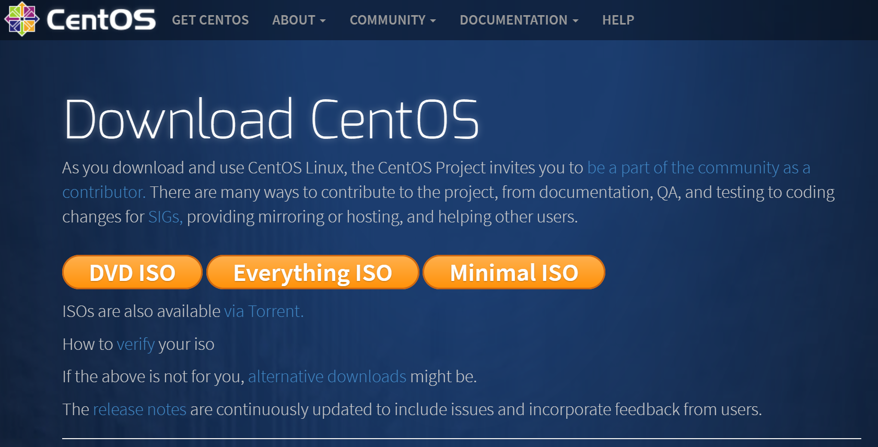

While the image was downloading, I researched the hardware requirements for the server. Due to a license change, an official manual is not available for any release after CentOS-5, there are however release notes for changes with each release. The minimum amount of RAM is shown to be 1024 MB in the release notes of the latest version of CentOS-7, however there is a known issue that can cause install failures when using 1024 MB of RAM (“CentOS-7 (1611) Release Notes”, 2016). For this reason, I have decided to assign 2048 MB of RAM to the virtual machine. This research took me 30 minutes to complete due to the confusing issue with licensing of the official manual.

After completing this research, I was ready to start configuring my VM and install CentOS. I started VirtualBox and configured a VM with 2048 MB of RAM and chose to create a virtual hard disk during the configuration.

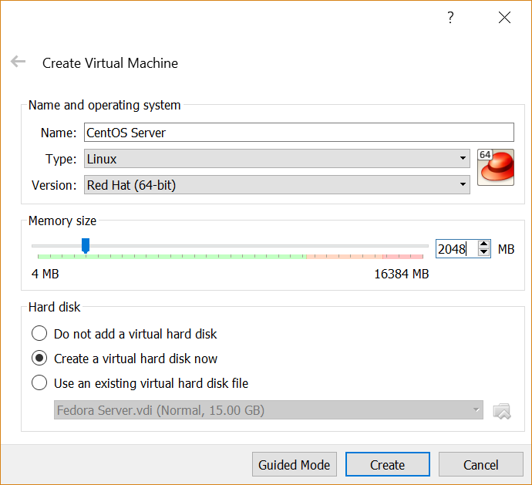

Since I have no need for cross-compatibility, I chose to use VDI as the hard disk file type as it is the native file type (Oracle Corporation, 2017, section 5.2).

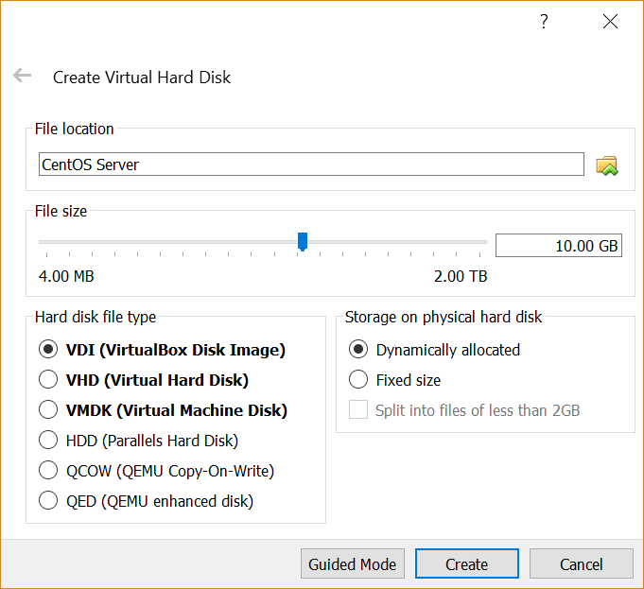

After completing the configuration, I booted the VM and selected the CentOS image that I had downloaded earlier.

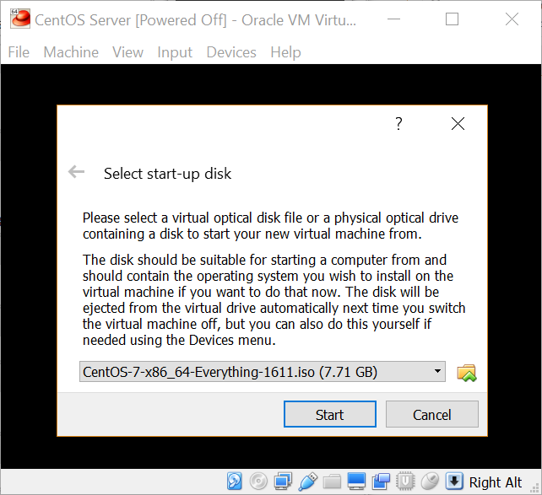

The VM then booted from the ISO. I chose the “Install CentOS Linux 7” option from the boot menu.

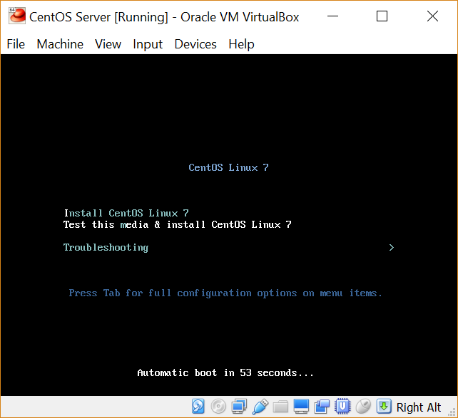

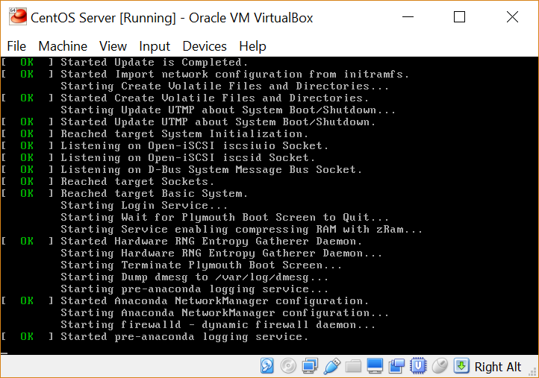

After the VM had finished booting from the ISO, I was greeted with the language selection menu.

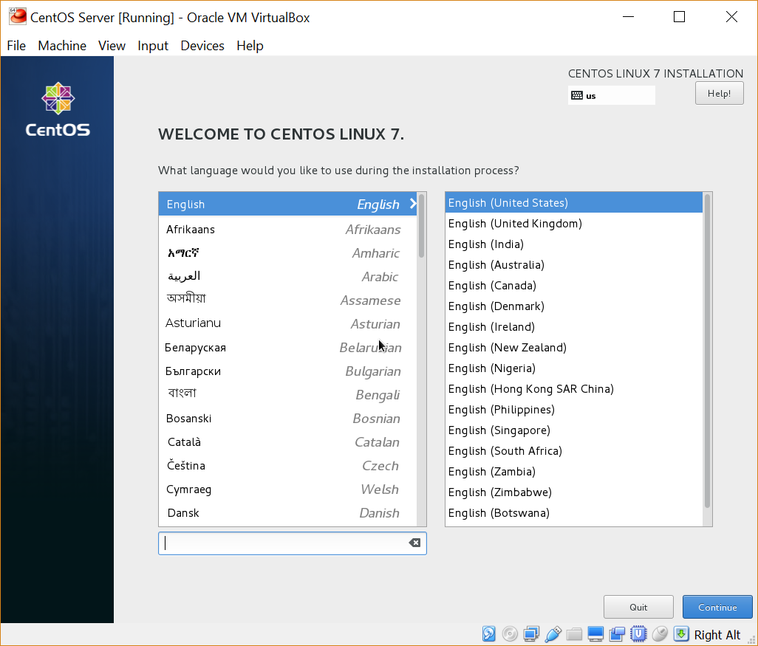

I then chose the language and location and then the Installation Summary screen was presented.

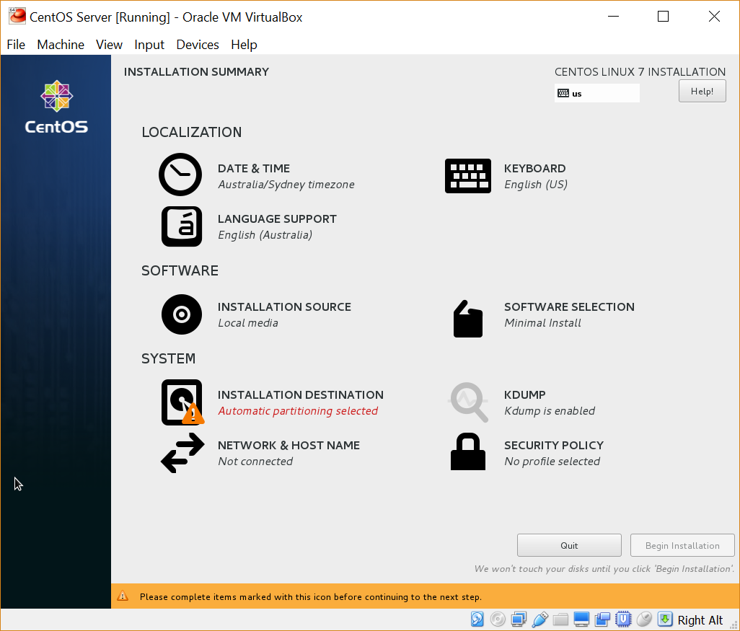

I clicked on the Software Selection option. At this point I contemplated which sort of installation I would like to proceed with. After doing some research on the different install variants, I decided upon using a minimal install as I would be staying true to the philosophy of Linux – “less is more”. Any additional components that I would require to achieve what I was required to complete during my assessment, I would simply find a way to install it later. I figured that this would provide me with a better learning experience overall. I spent approximately half an hour researching and contemplating this step.

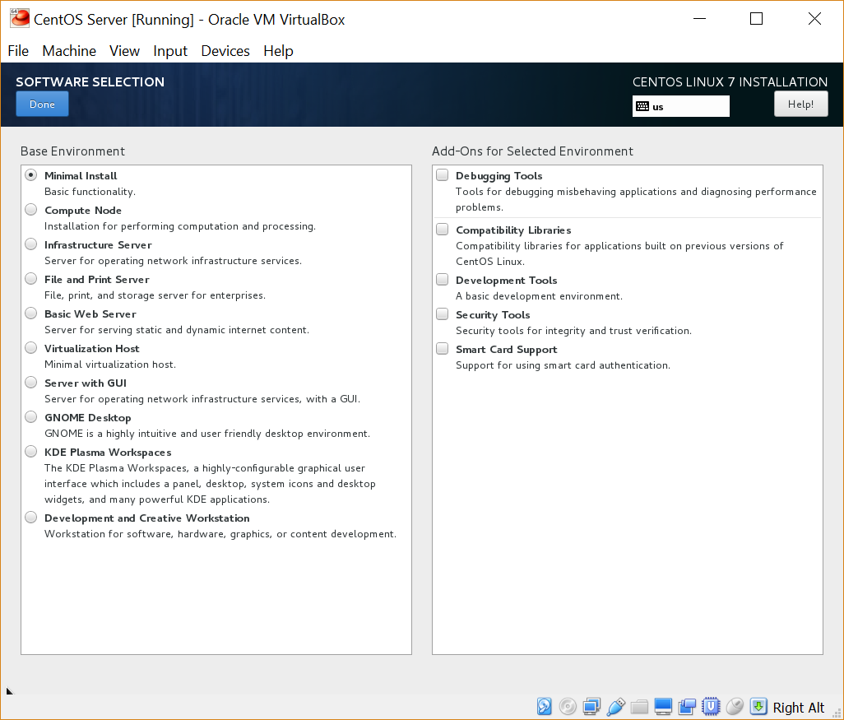

I then chose the installation destination as the virtual hard disk that I had configured earlier.

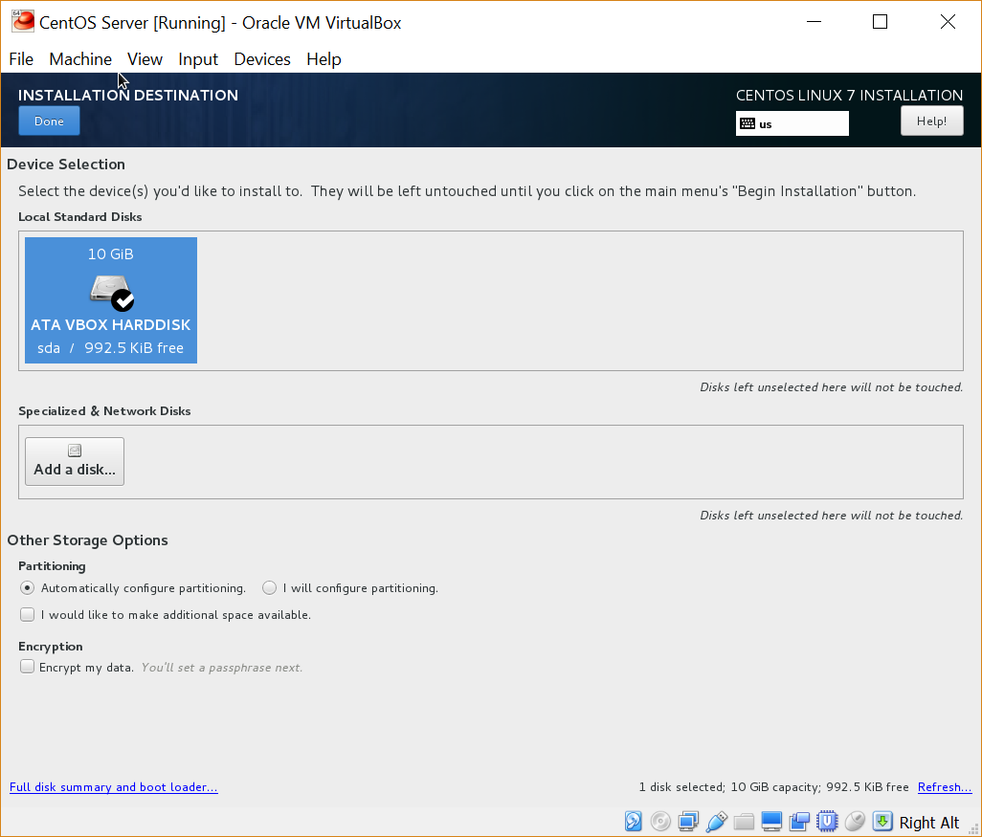

The network adapter was disabled by default, so I enabled it and configured the hostname of my server to be CentOS.

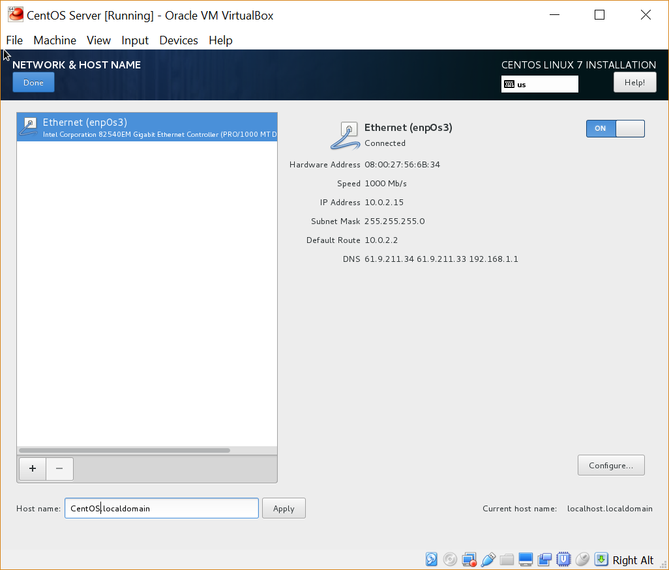

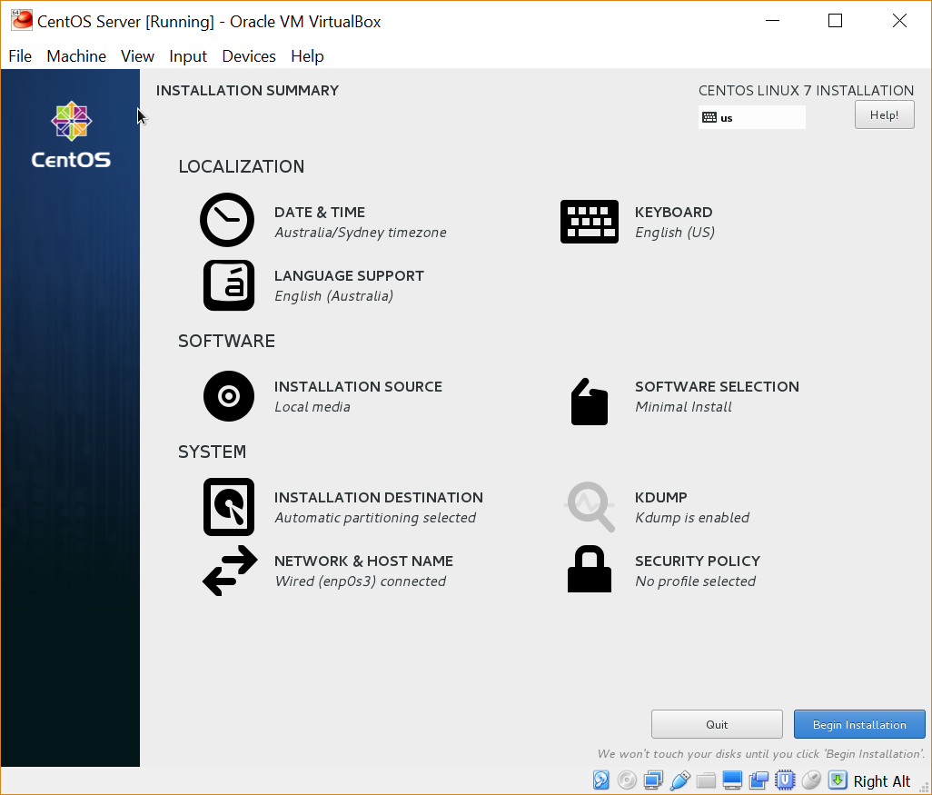

From Installation Summary, I then clicked on “Begin Installation” which took me to a User Settings menu.

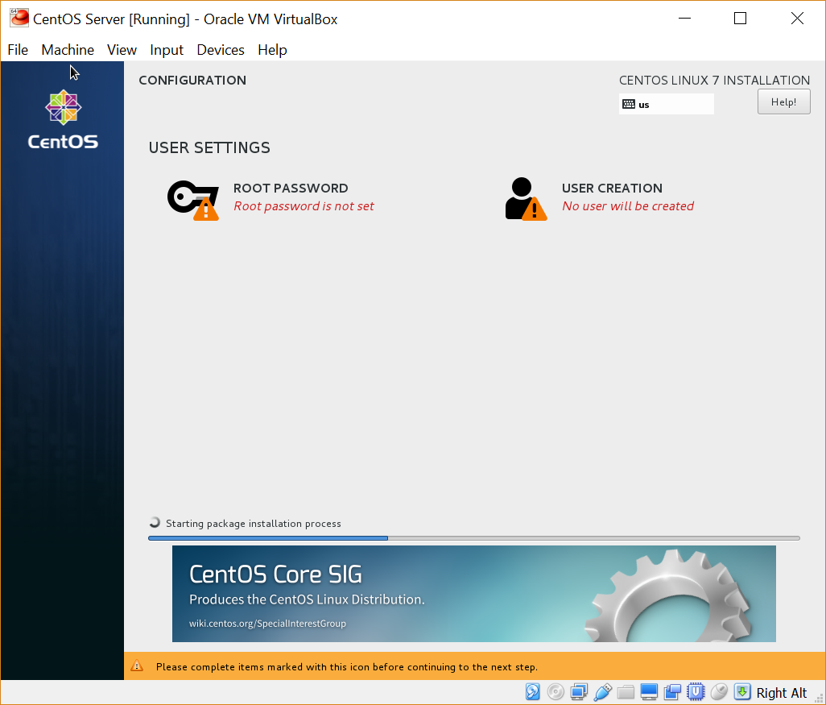

I configured both a root password and an administrator account called “admin”.

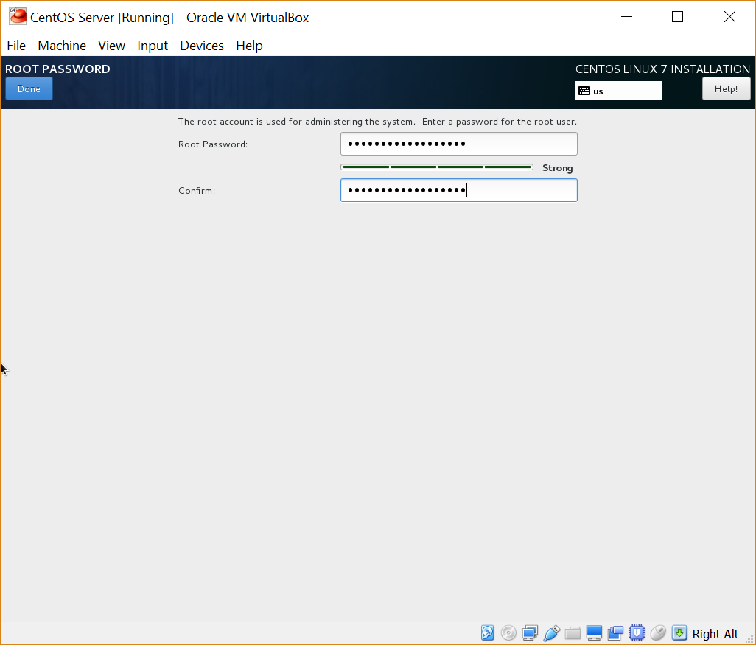

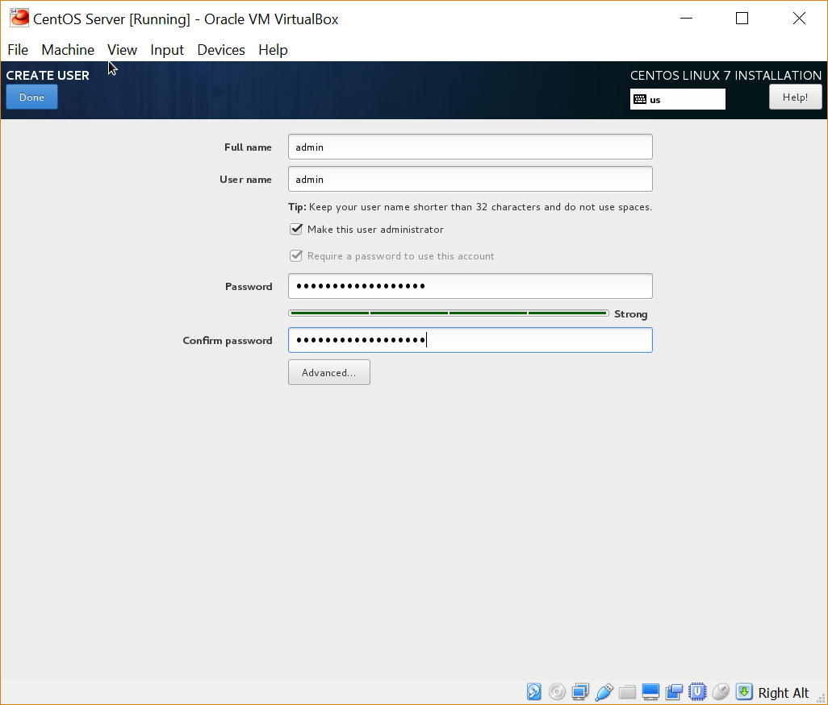

I clicked on “Finish Configuration” and the operating system then began installing.

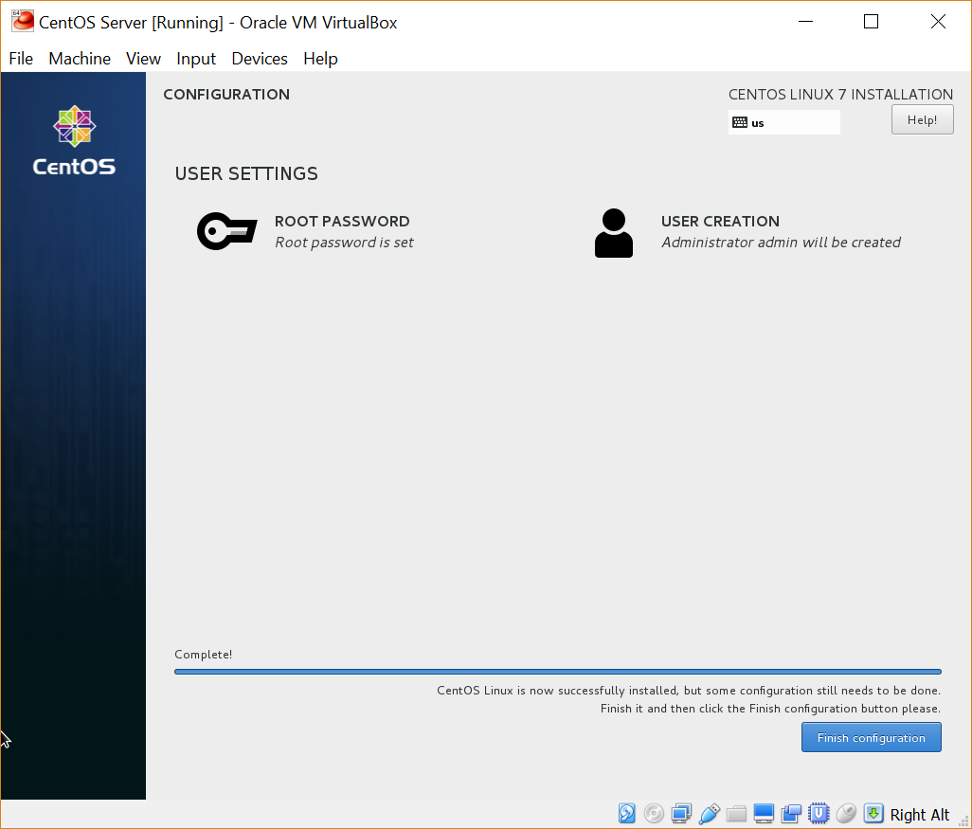

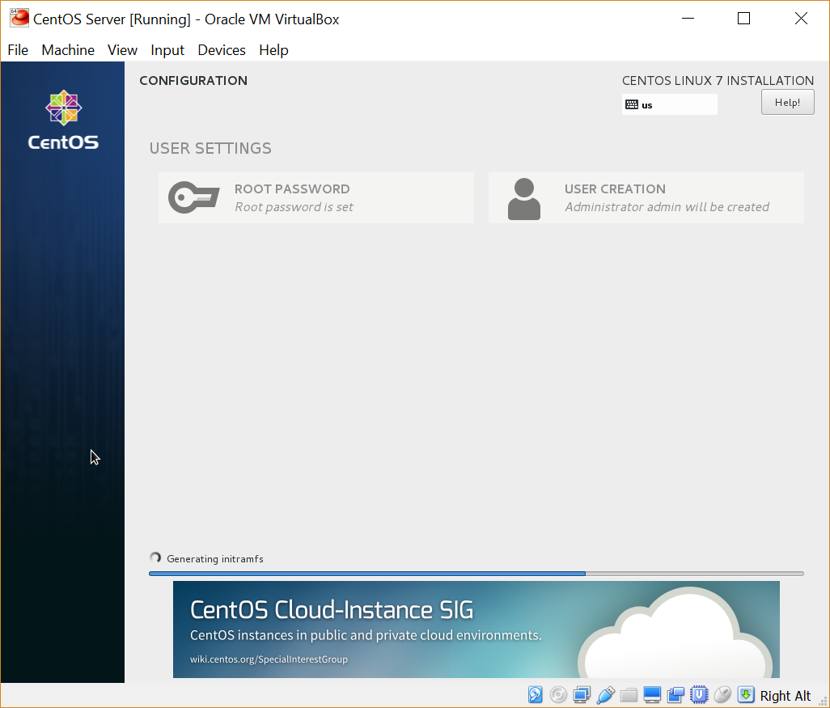

Once the installation was completed, I clicked on reboot. This install and configuration stage took approximately an hour to complete.

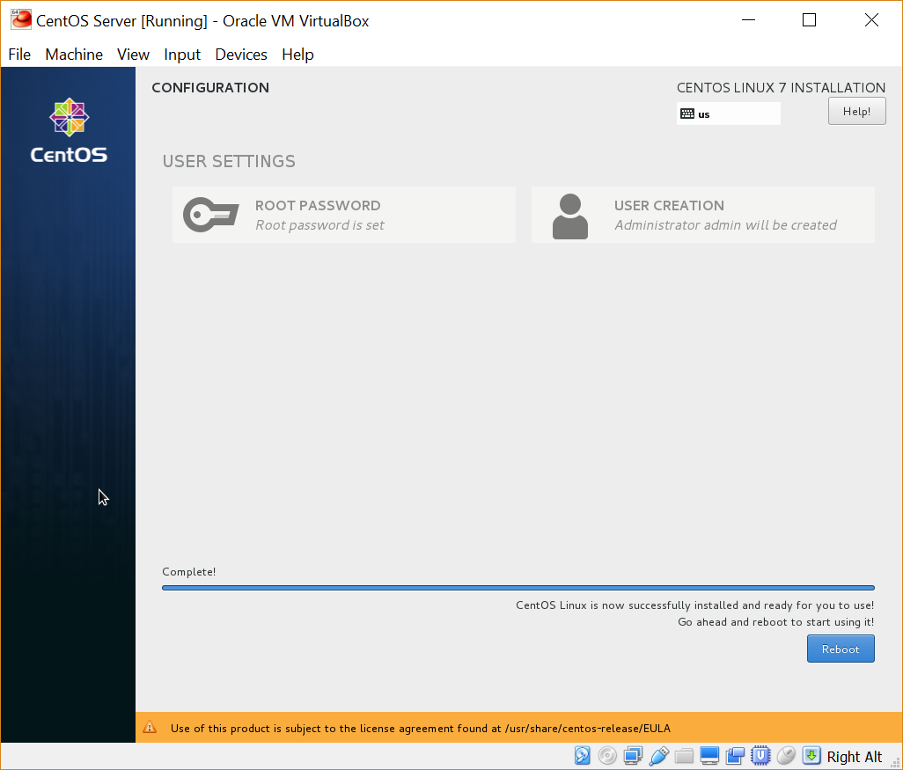

The VM rebooted and showed a command line interface (CLI) requesting a login.

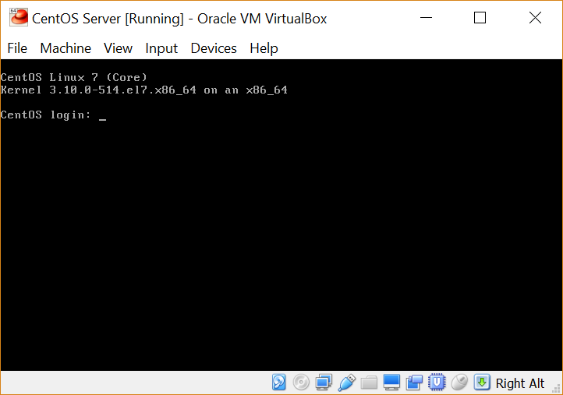

I tested the root password that I had setup during configuration. I mistyped the password on the first attempt, but that showed me that CentOS has an “incorrect password attempt” notification, which is a desirable inclusion in an operating system used in an enterprise server environment.

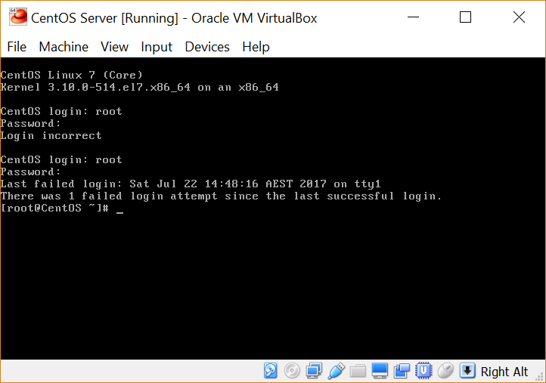

After installation and configuration was complete, I got myself comfortable with traversing the folder structure, creating directories, and modifying file and folder permissions. During this time, I felt that the low resolution of the CLI was making me feel uncomfortable. I decided that I would install a GUI so that I would feel a bit more comfortable while learning a new system. I researched different GUIs that are available, and ended up installing GNOME as it seems to be known as one of the better GUIs. I used the following guide - <https://unix.stackexchange.com/questions/181503/how-to-install-desktop-environments-on-centos-7> as evident by the following steps.

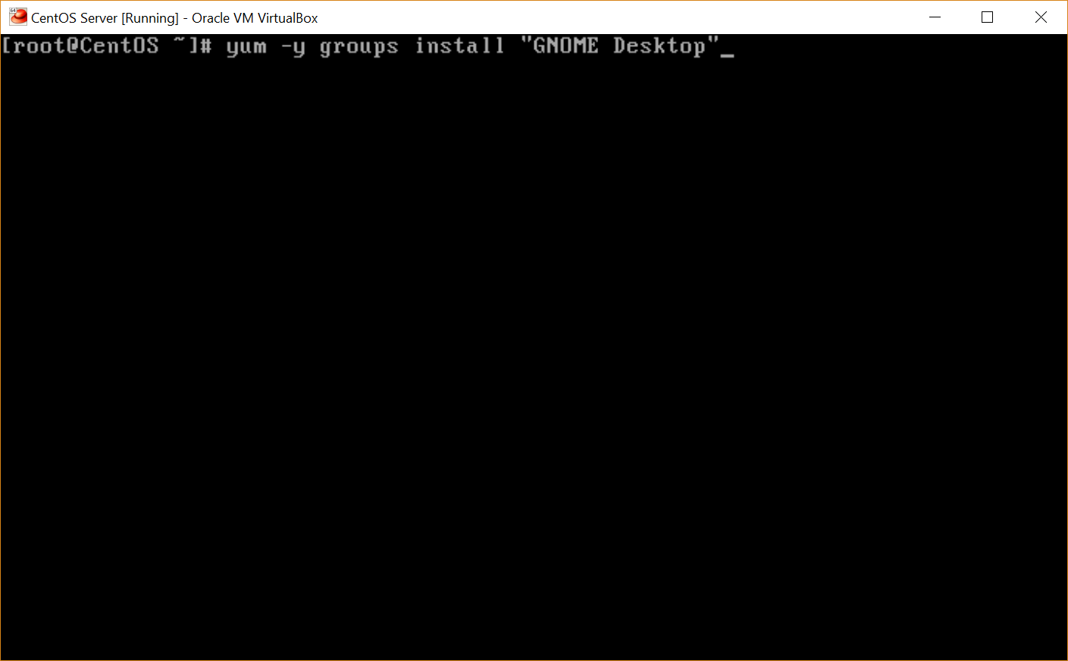

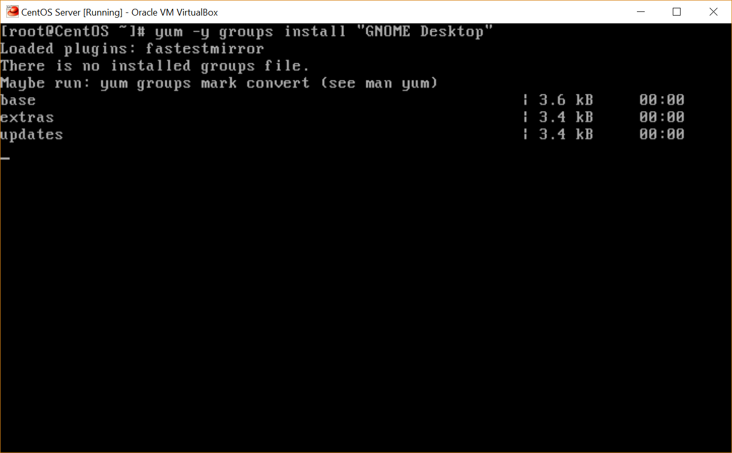

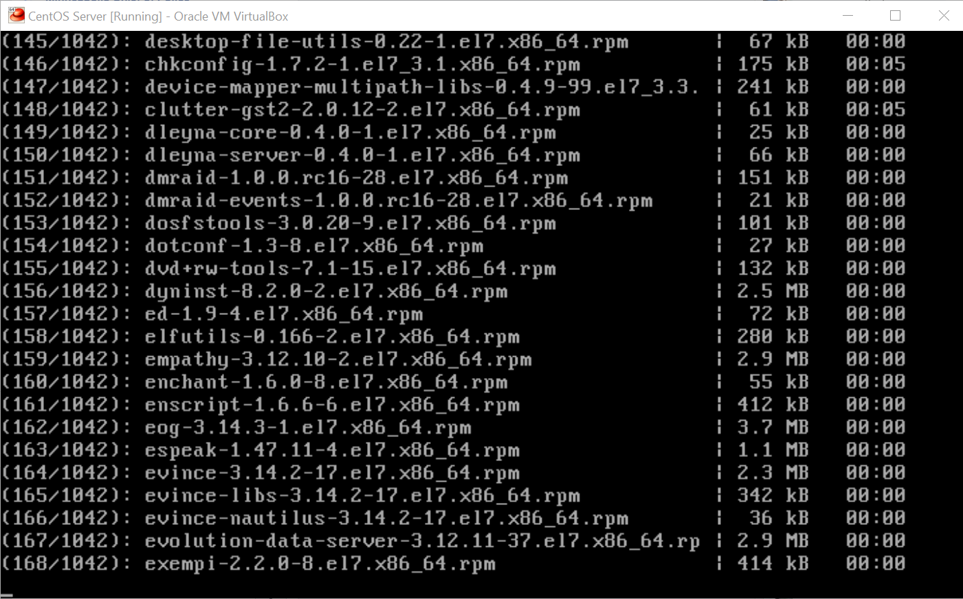

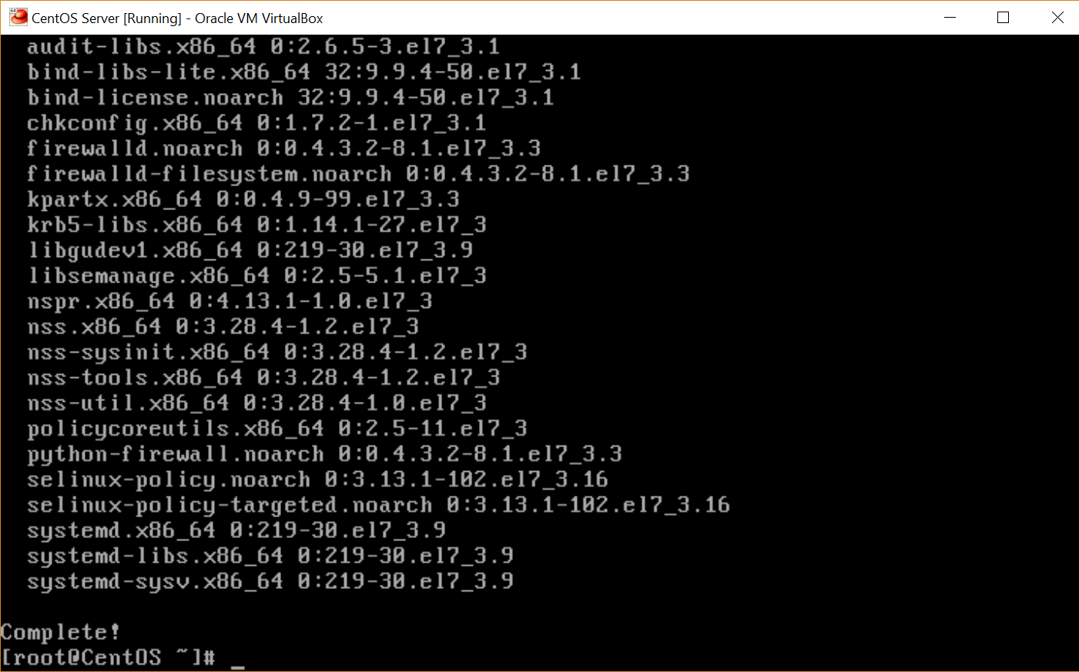

Once the installation was complete, I ran “startx” to start GNOME.

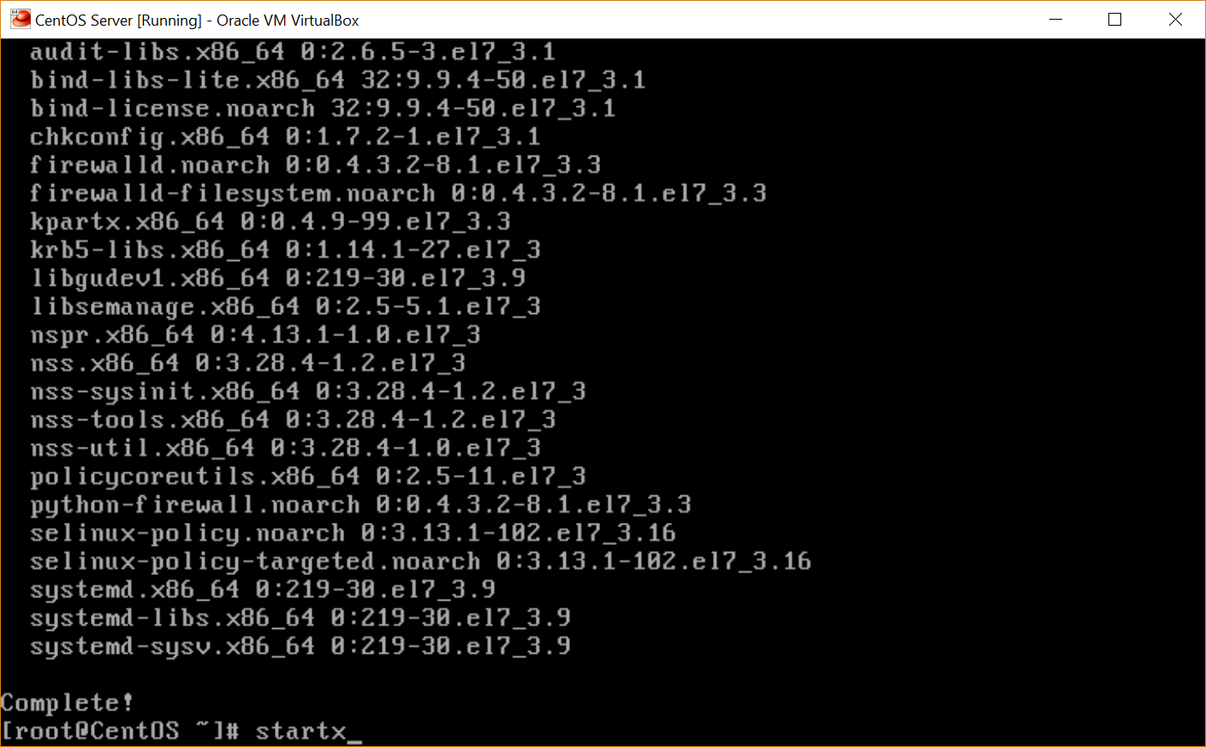

I then stepped through the configuration of GNOME.

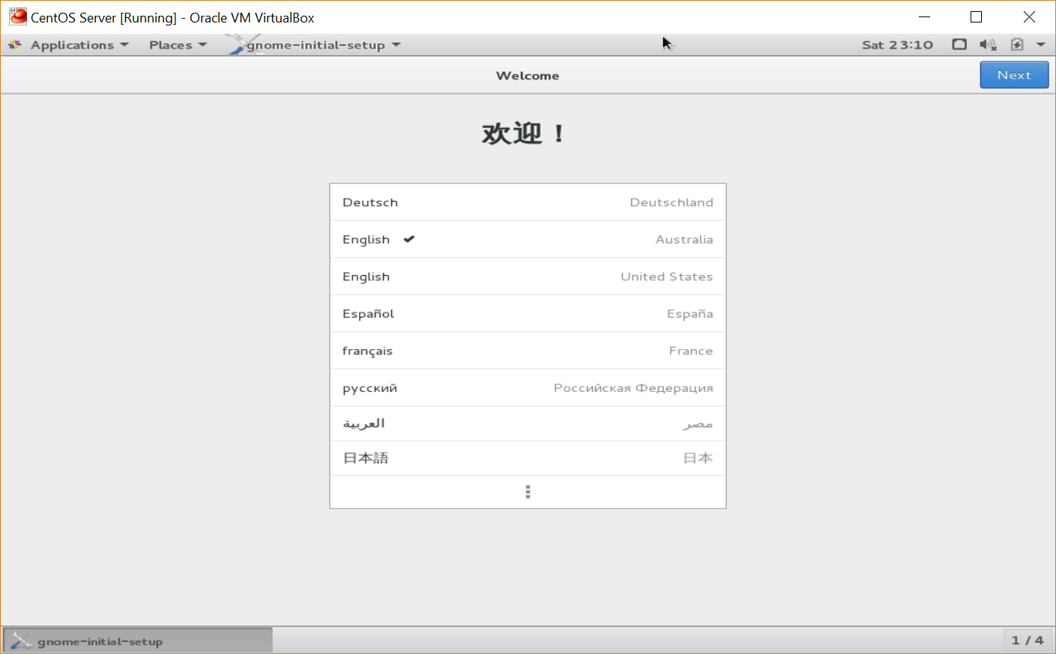

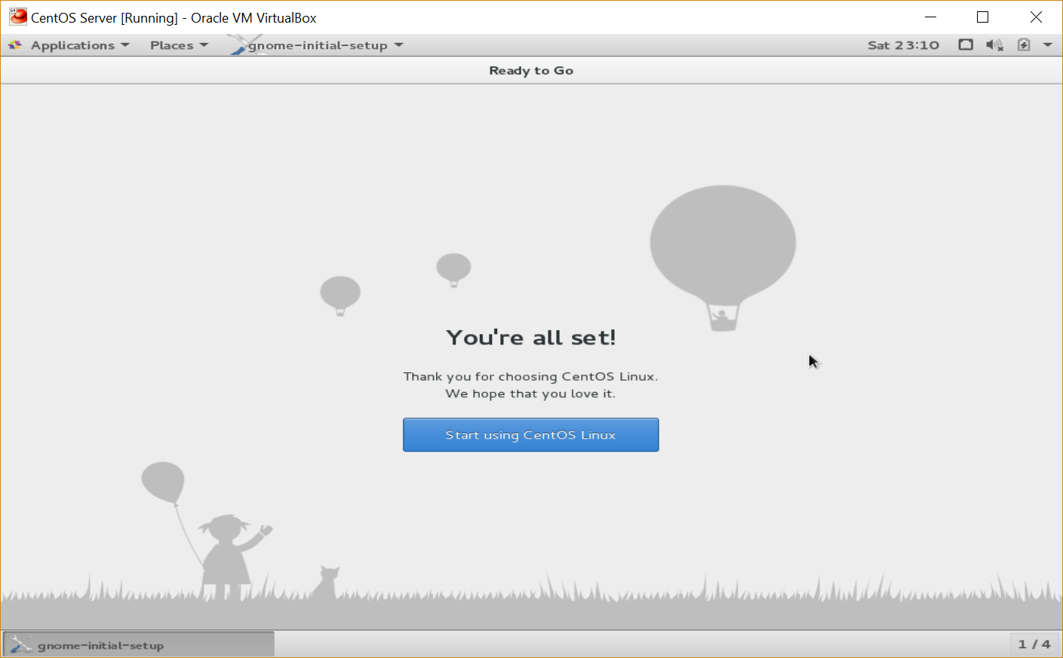

Once the installation and configuration was completed, I noticed that the resolution was still very low. I researched the issue and found that I need to install Guest Additions for VirtualBox. I mounted the Guest Additions ISO to VirtualBox and ran the installation.

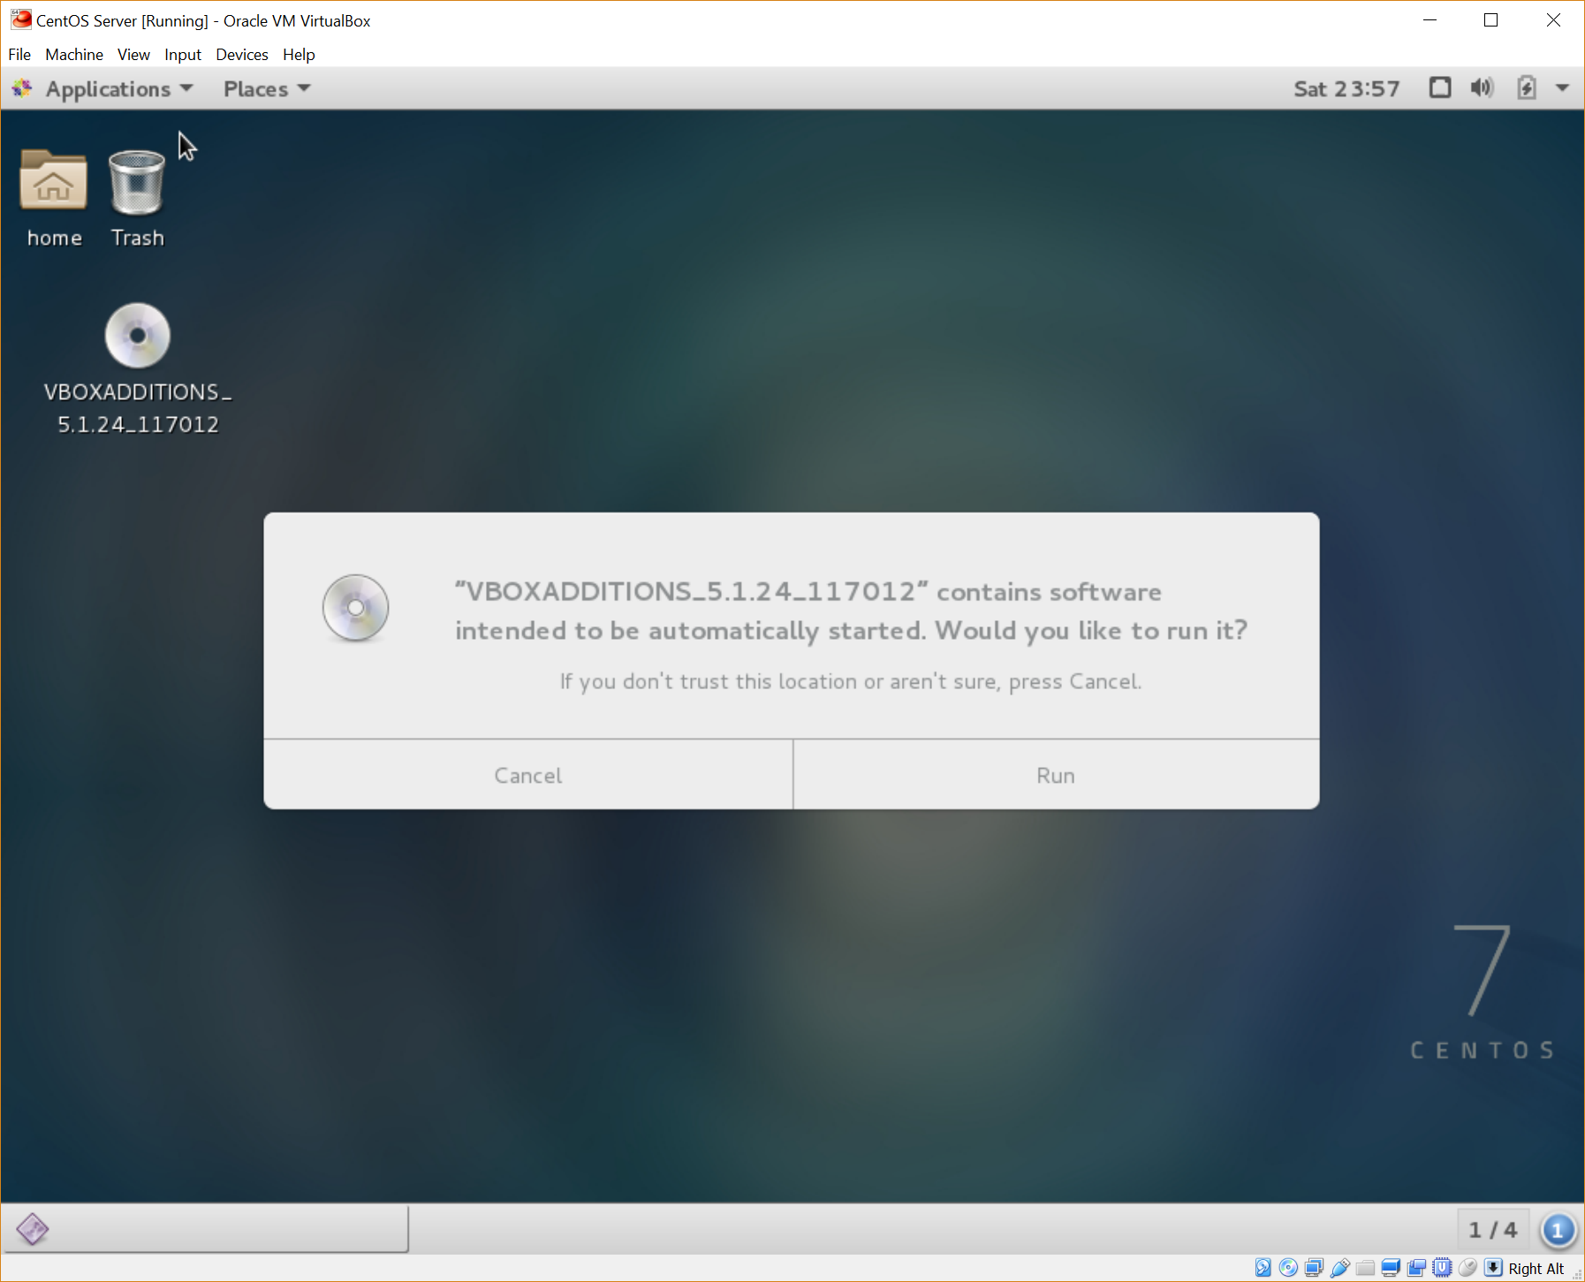

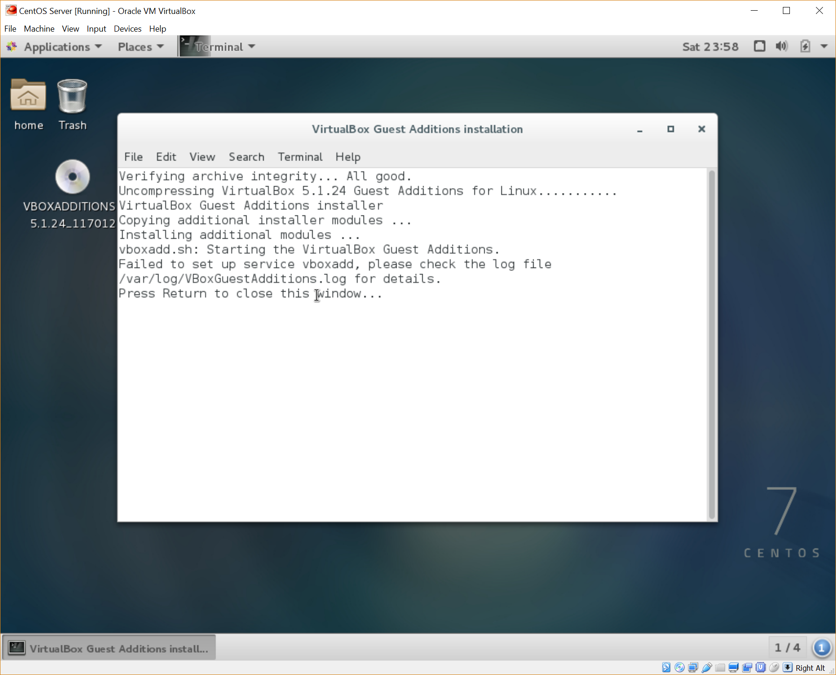

The installation failed, so I searched for the log files in order to research the issue.

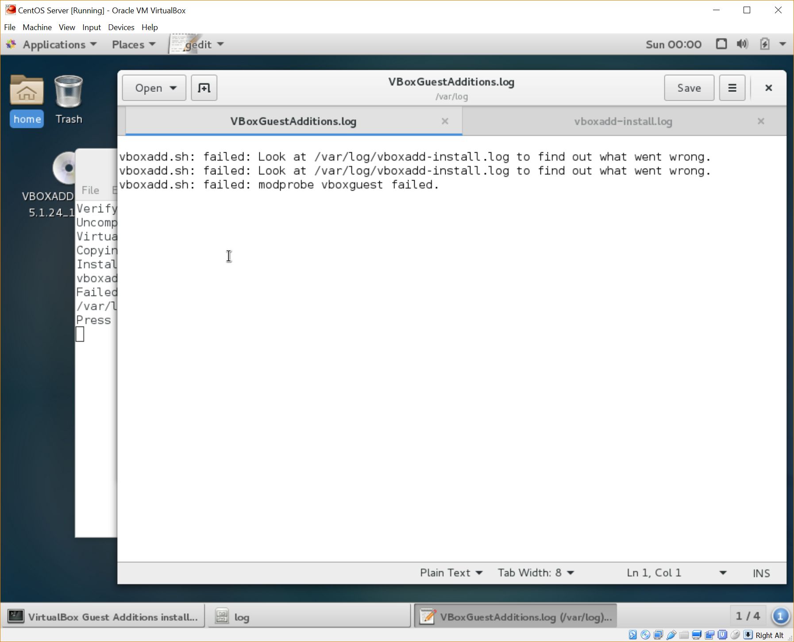

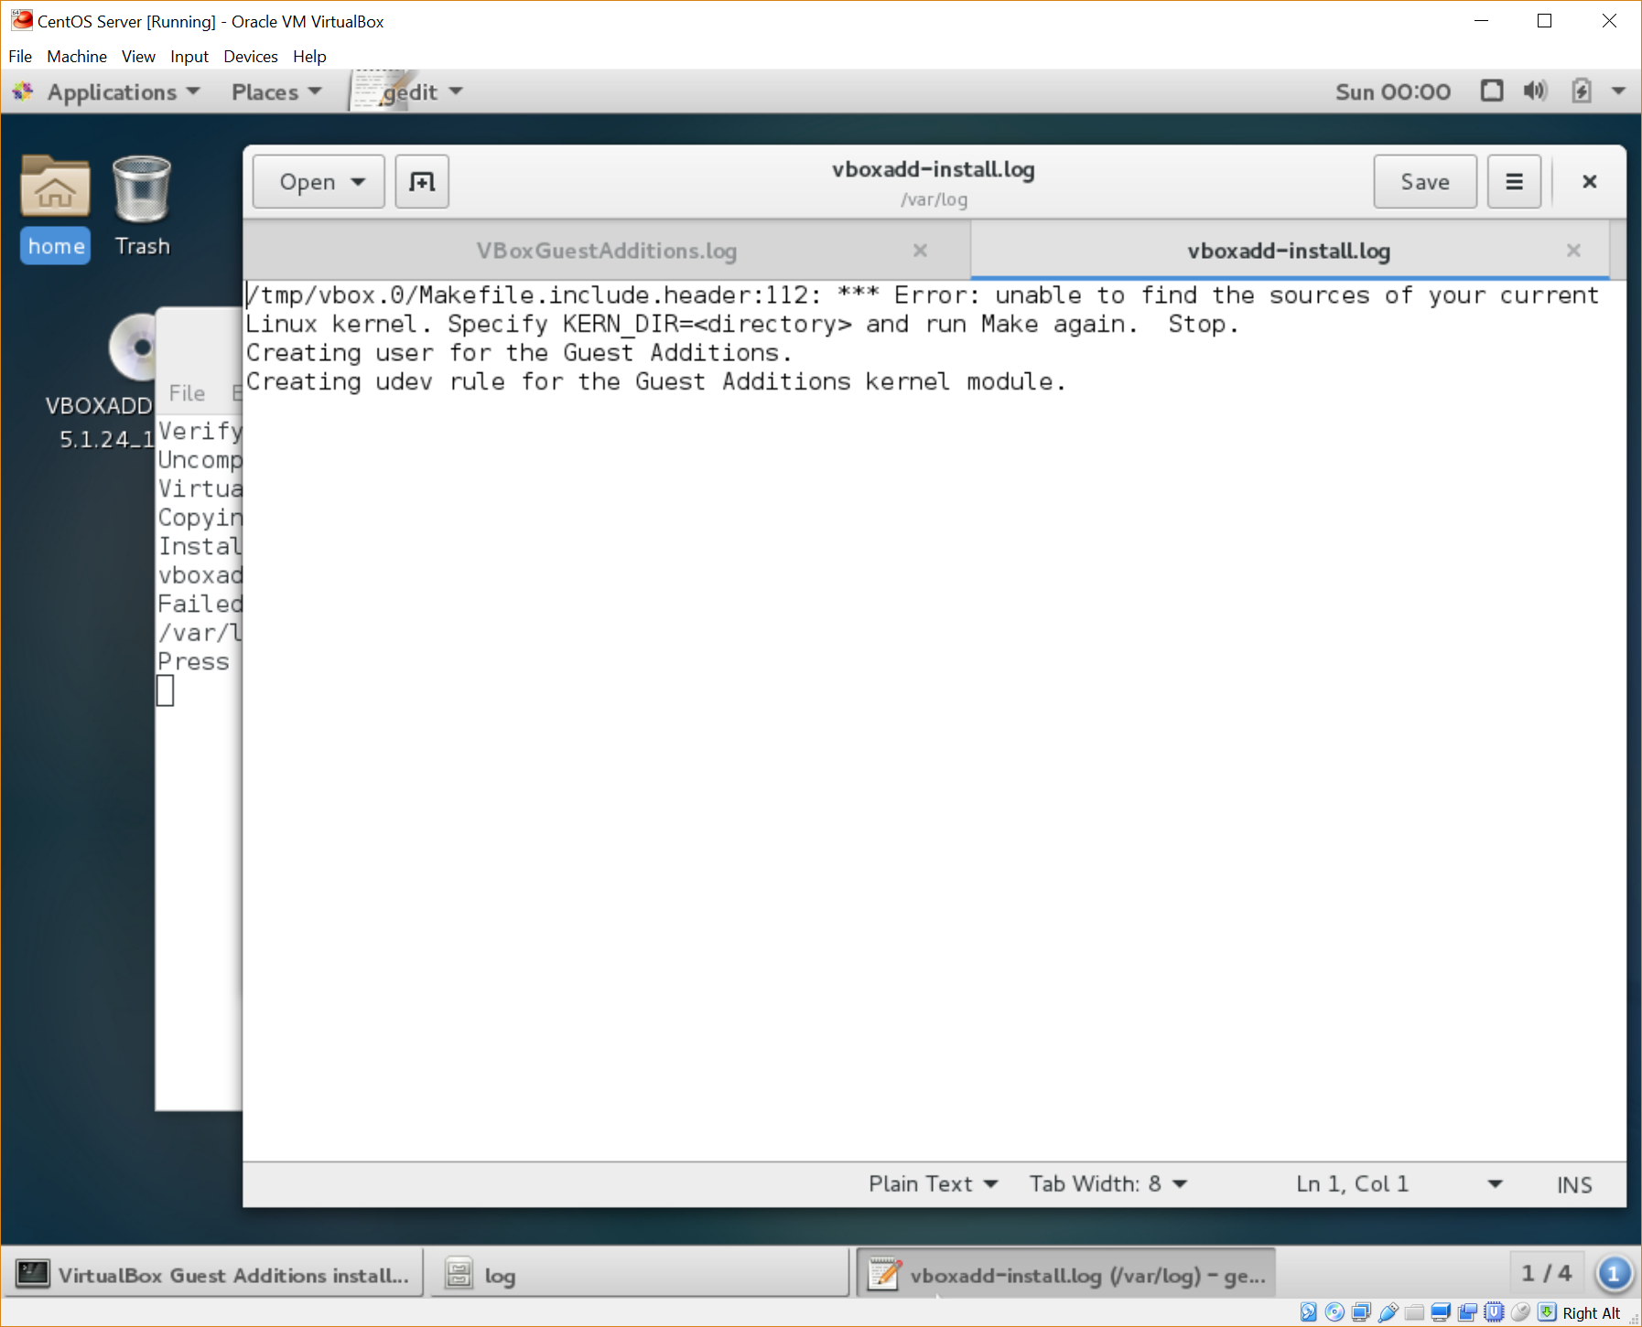

While researching the errors from the log files, it seemed like I needed to update kernel-devel and kernel-headers as shown in the following link - <https://www.centos.org/forums/viewtopic.php?t=45163>.

I first ran the “yum update” command which attempts to update all installed packages.

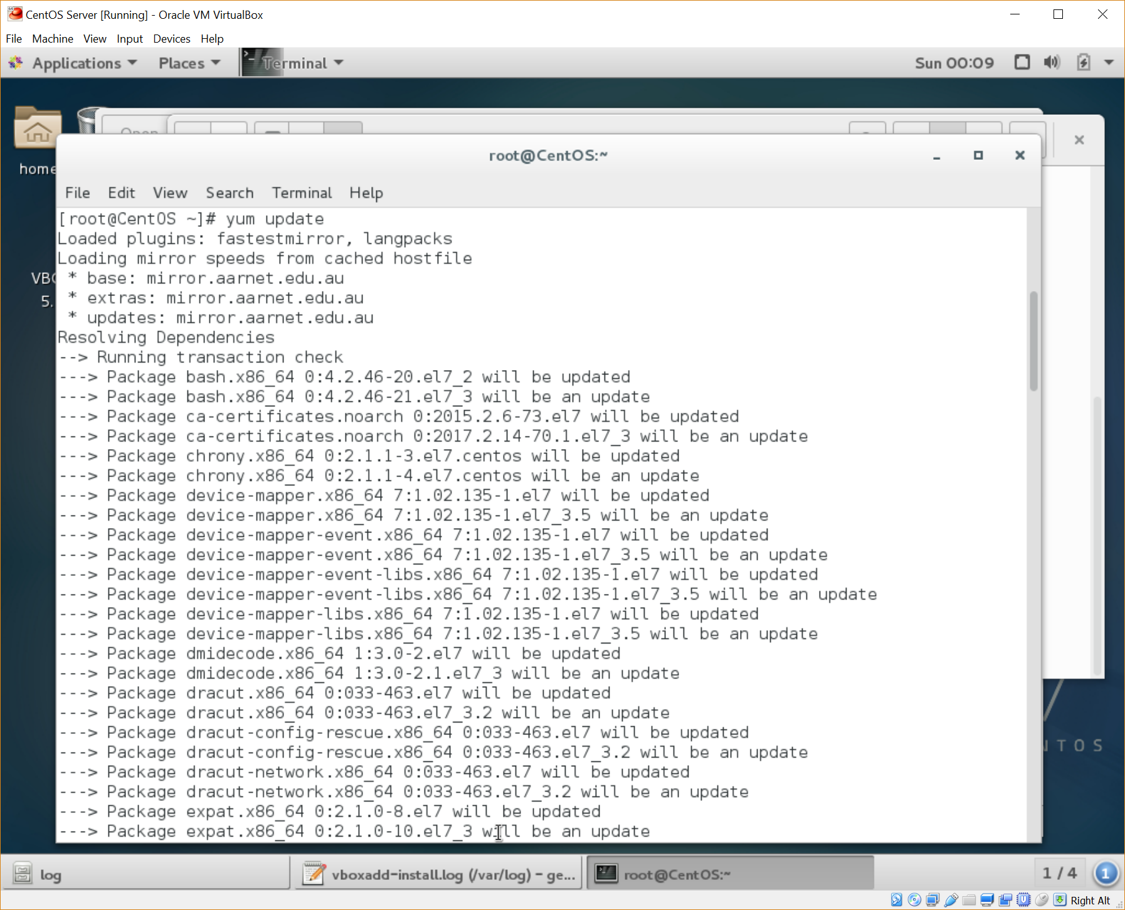

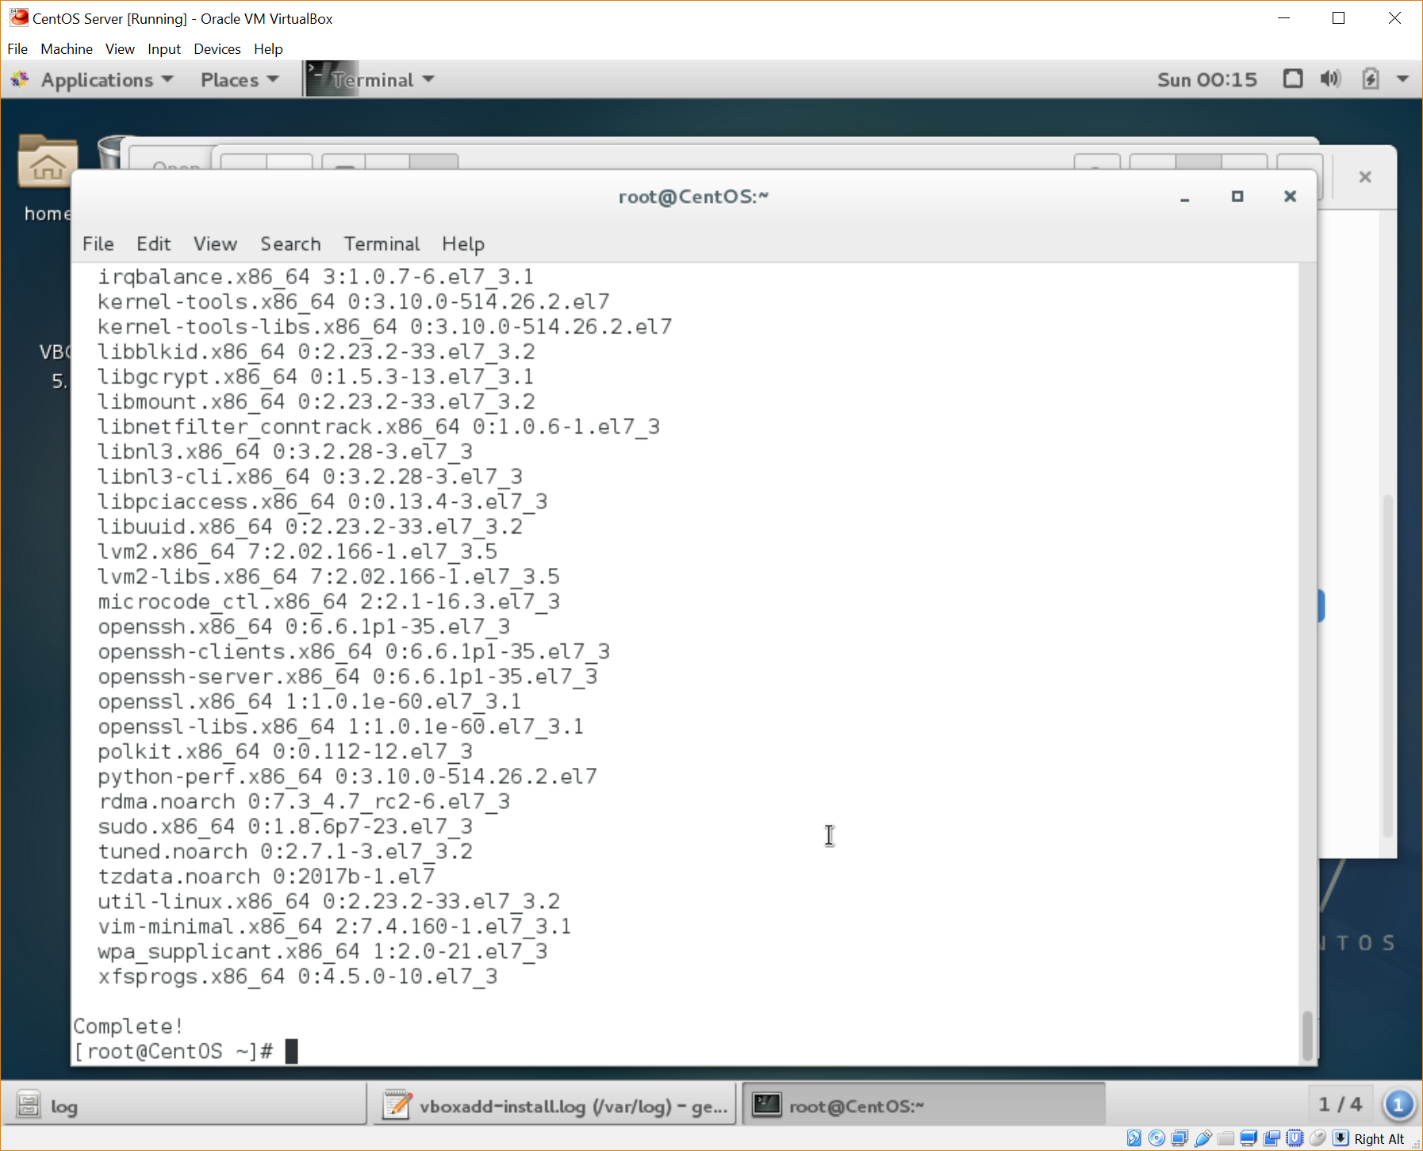

After this update was completed, I ran the “yum install” command for kernel-headers and kernel-devel, which installed the latest versions of these packages.

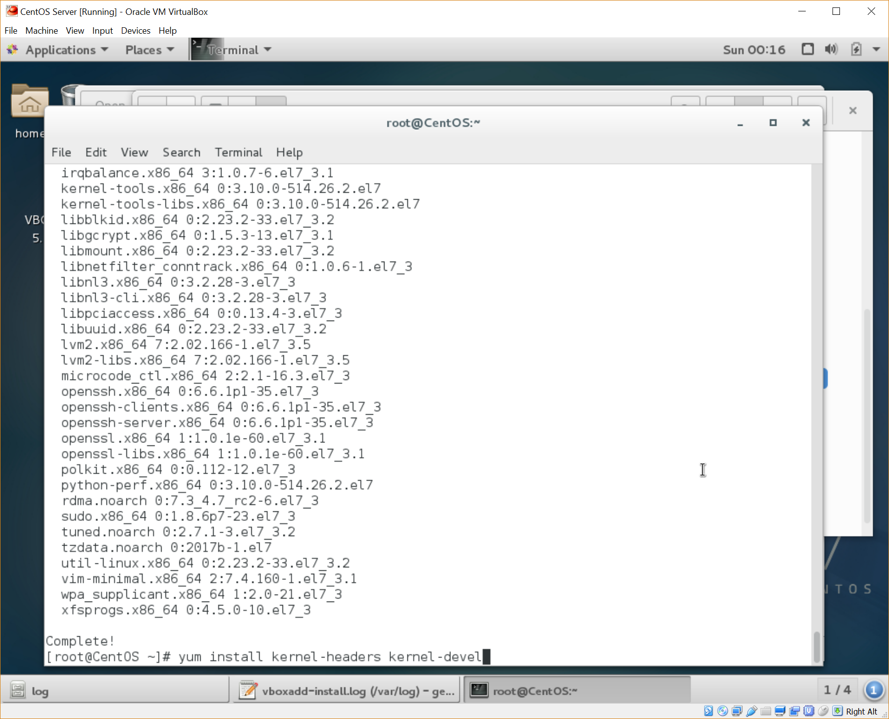

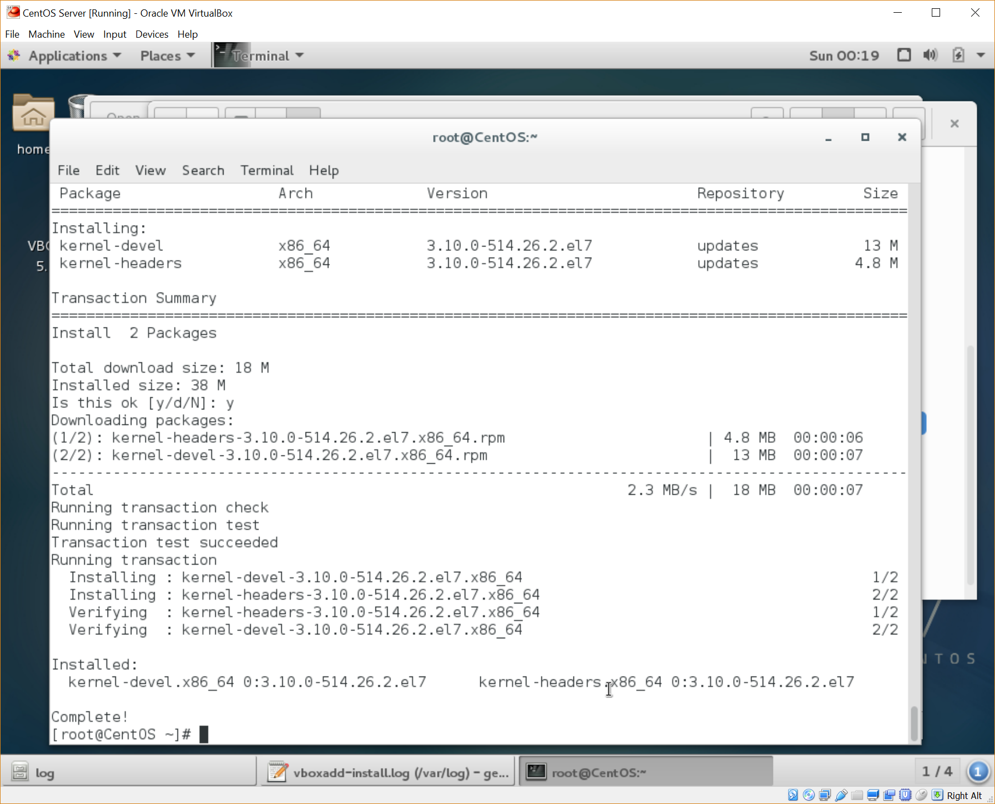

After these were installed, I tried to run the Guest Additions install again to no avail. The same errors were occurring.

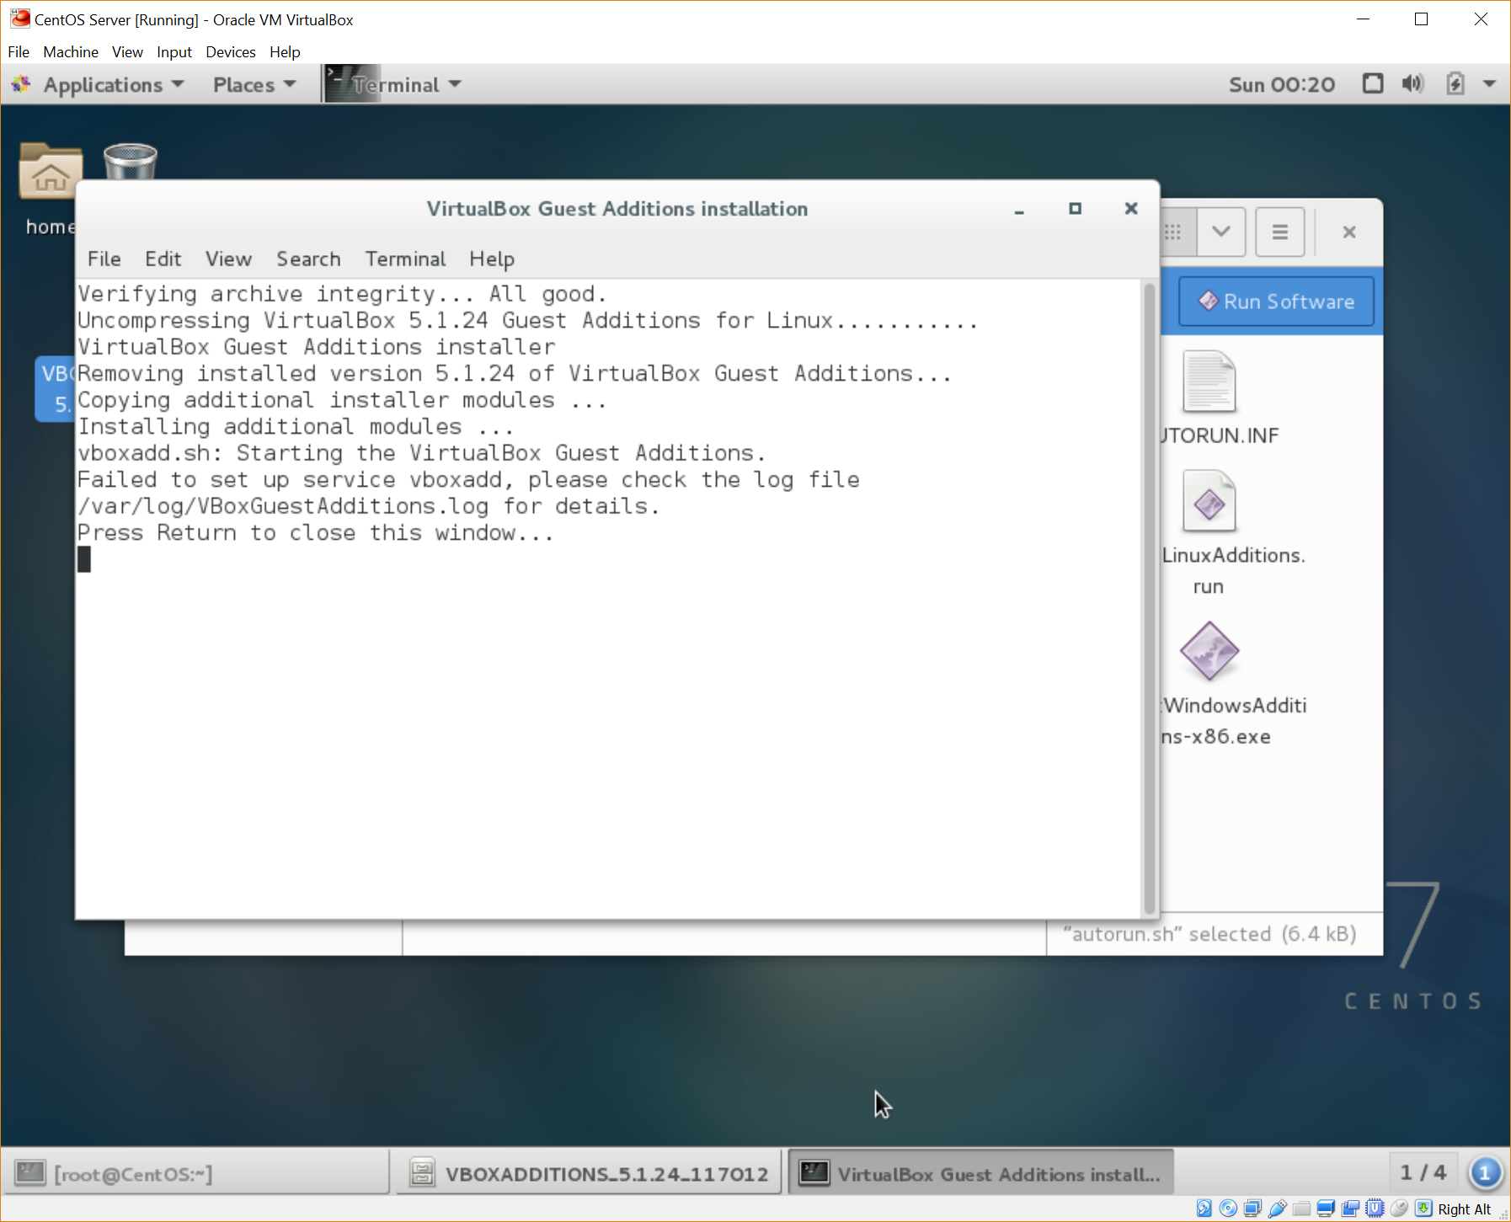

I then tried running the file from the terminal using “sh” command.

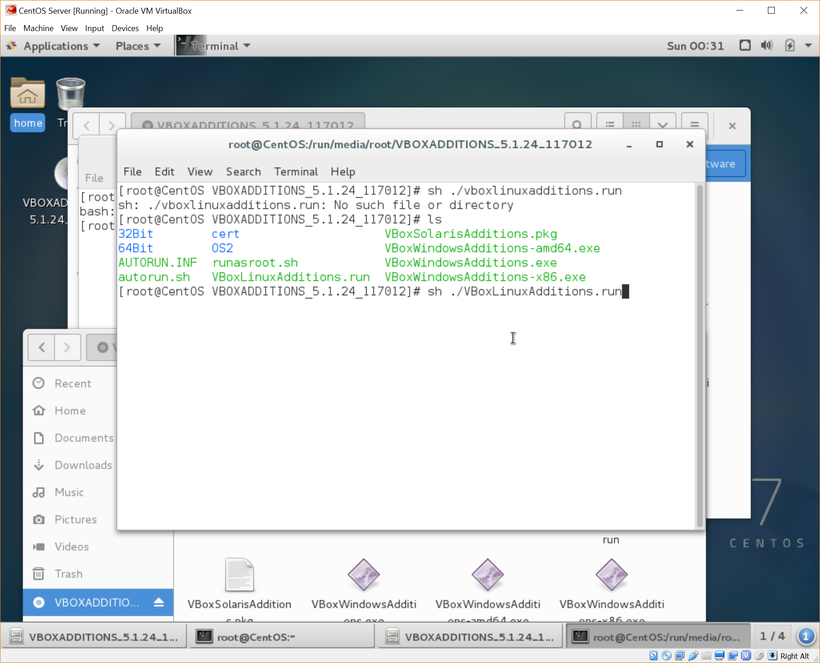

Running from the terminal did not change the issue though. Did some further research and found that the issue might be due to old kernel and kernel-devel packages - <https://www.centos.org/forums/viewtopic.php?f=13&t=4047&start=10>

I used the “uname -r” command to find the current kernel version.

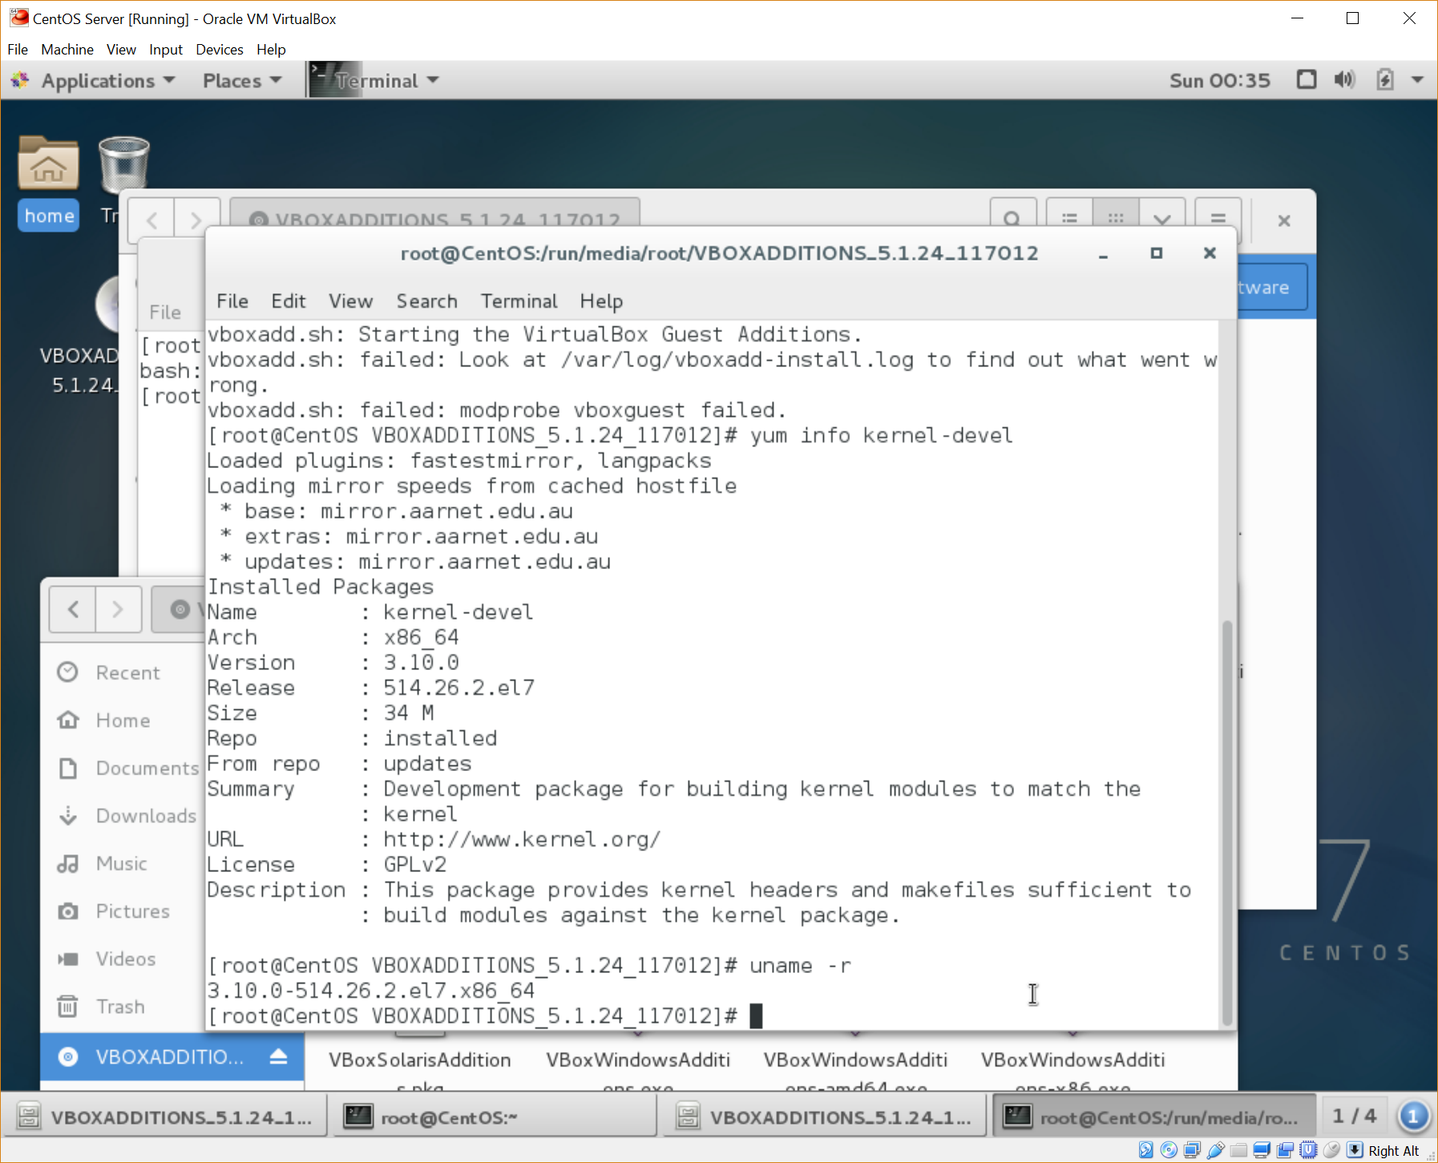

I then used “rpm -qa” with grep and sort to show the currently installed kernel packages. There was an old kernel version installed. I used “rpm -e” to remove the old kernel version.

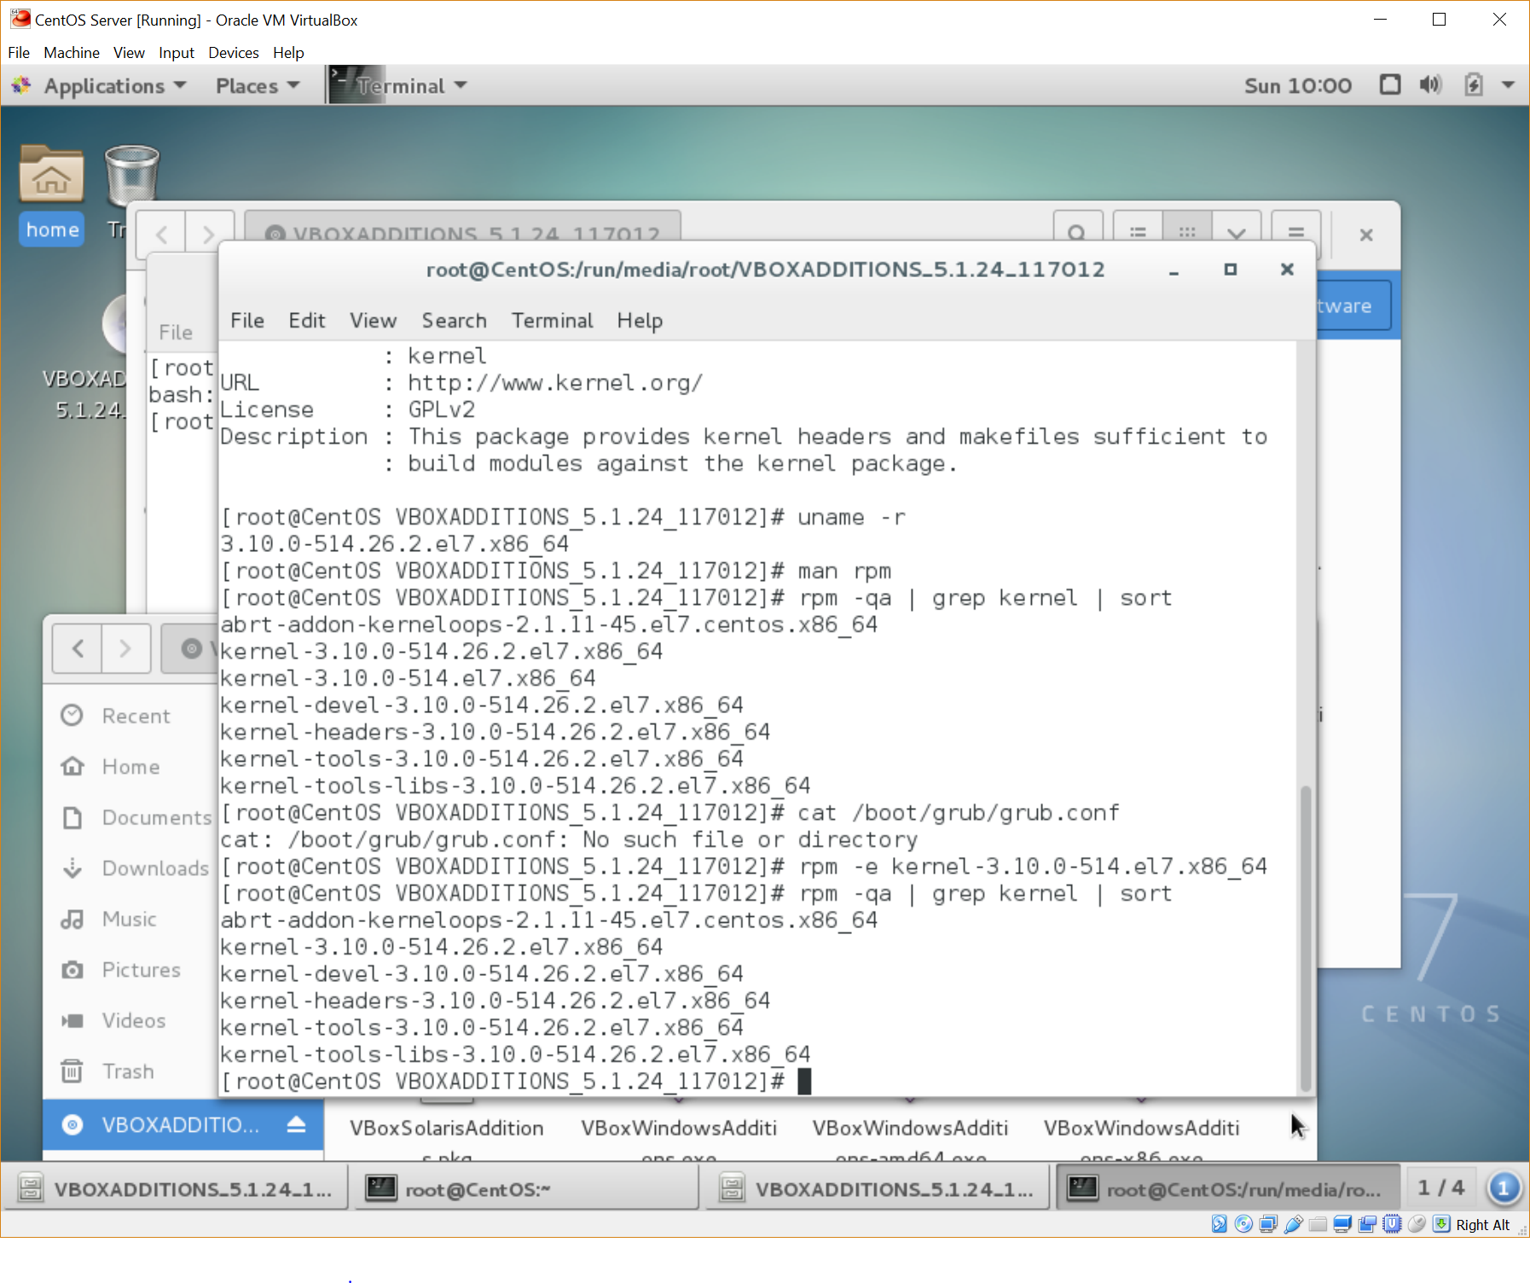

However, the same error still occurred when attempting to install Guest Additions.

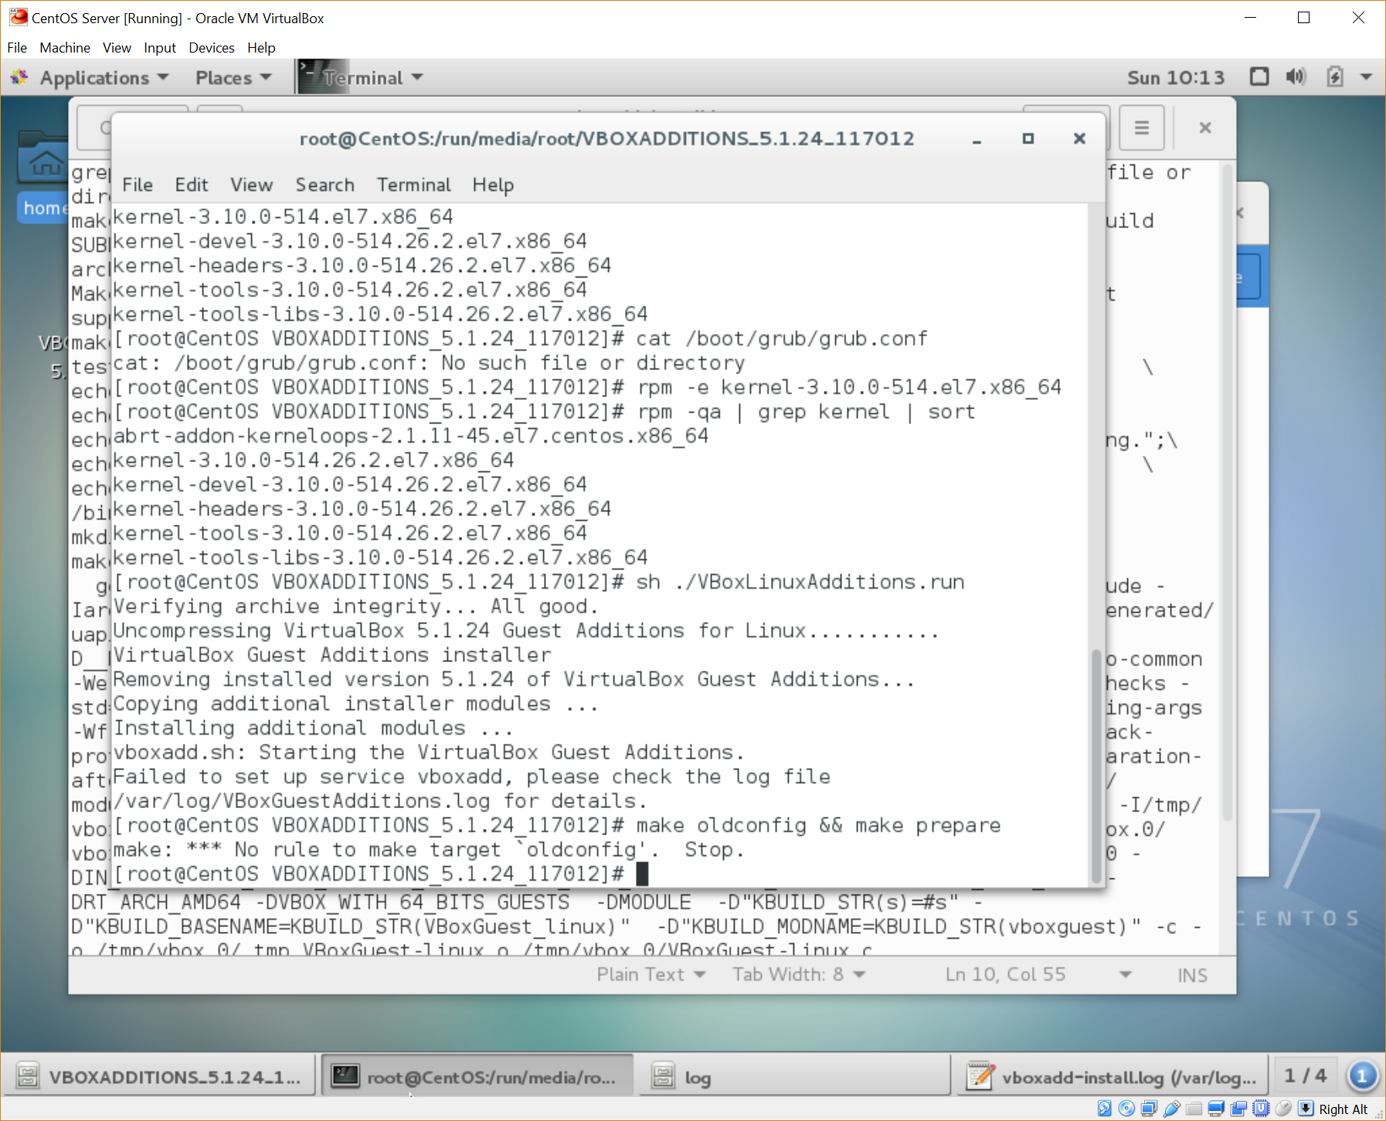

After spending 3 hours researching this issue and attempting multiple things to fix it, I decided that the outcome wasn’t worth spending any more time on.

## Linux Processes

Firstly, I ran “top” from the terminal to retrieve a list of processes that are currently running on my linux system.

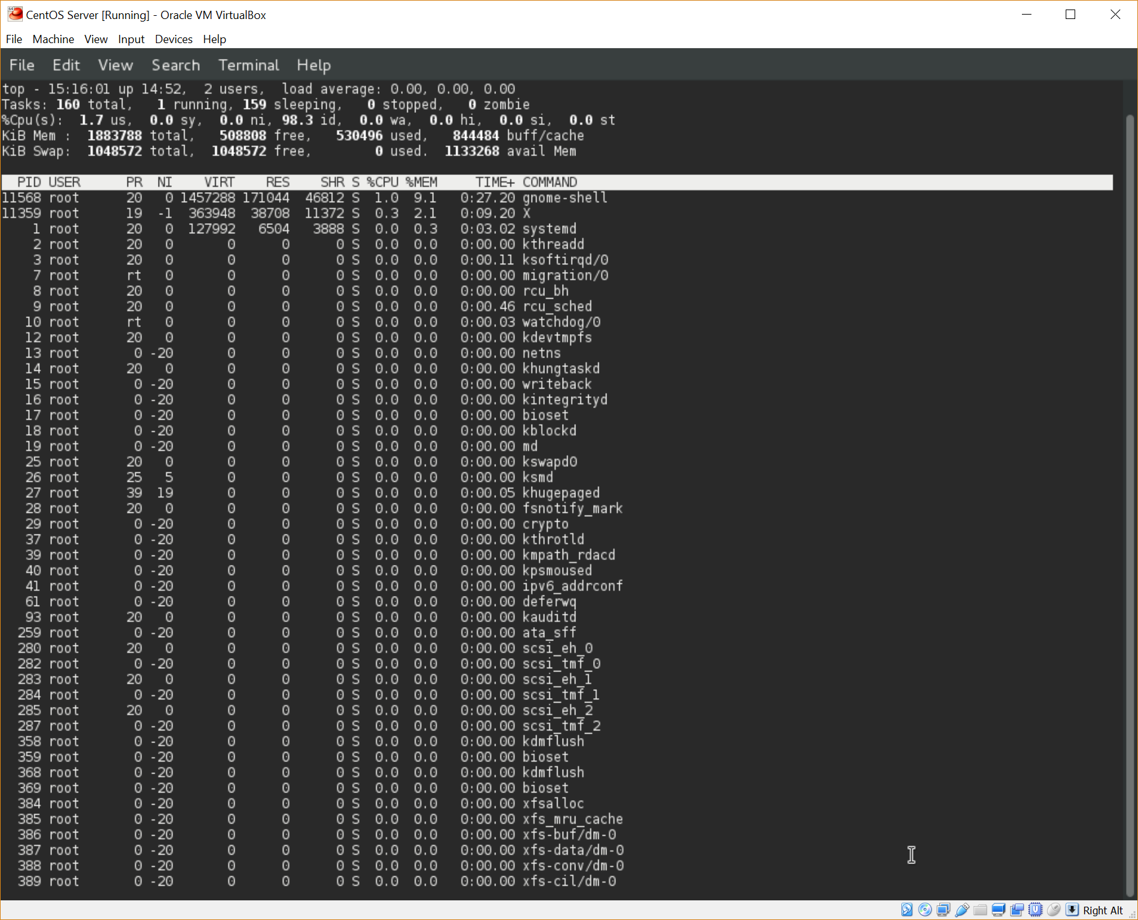

The 3 processes that I will explain in detail that are currently running on my CentOS server are gnome-shell, systemd, and watchdog.

“gnome-shell” is a process that handles the graphical shell of the GNOME desktop environment. This process manages all aspects of the graphical user interface that the user interacts with in order to manipulate the linux system to their desire. This process is similar in use to explorer.exe in Windows.

“systemd” is a suite of components pertaining to a wide array of functions of a Linux system. The process in question however, PID 1, is the daemon which initialises the booting of the user space, manages all other processes, and initialises daemons (“systemd System and Service Manager”, 2017).

“watchdog” is a daemon whose sole purpose is to keep an eye on the system status and reboot the system if needed (“watchdog(8) – Linux man page”, 2017). Watchdog has a list of tests that it runs to test the status of the system and if any of these tests fail or take longer than a minute, watchdog will initialise a system reboot.

The research required for this task took me an hour and a half to complete.

## Shell Script

I started Vi using “vi ass1script.txt” in a folder that I had created previously – “/scripts/”. The first requirement of the script is to display current system uptime. I researched the best way to display this information and found that the “uptime” command would be sufficient (“11.8. Uptime”, 2017). After inserting the “shebang”, I inserted a heading along with a border, followed by “uptime -p”. The -p switch shows a “pretty” version of the uptime information as shown by running “man uptime”. I then added a border of dashes after the uptime information.

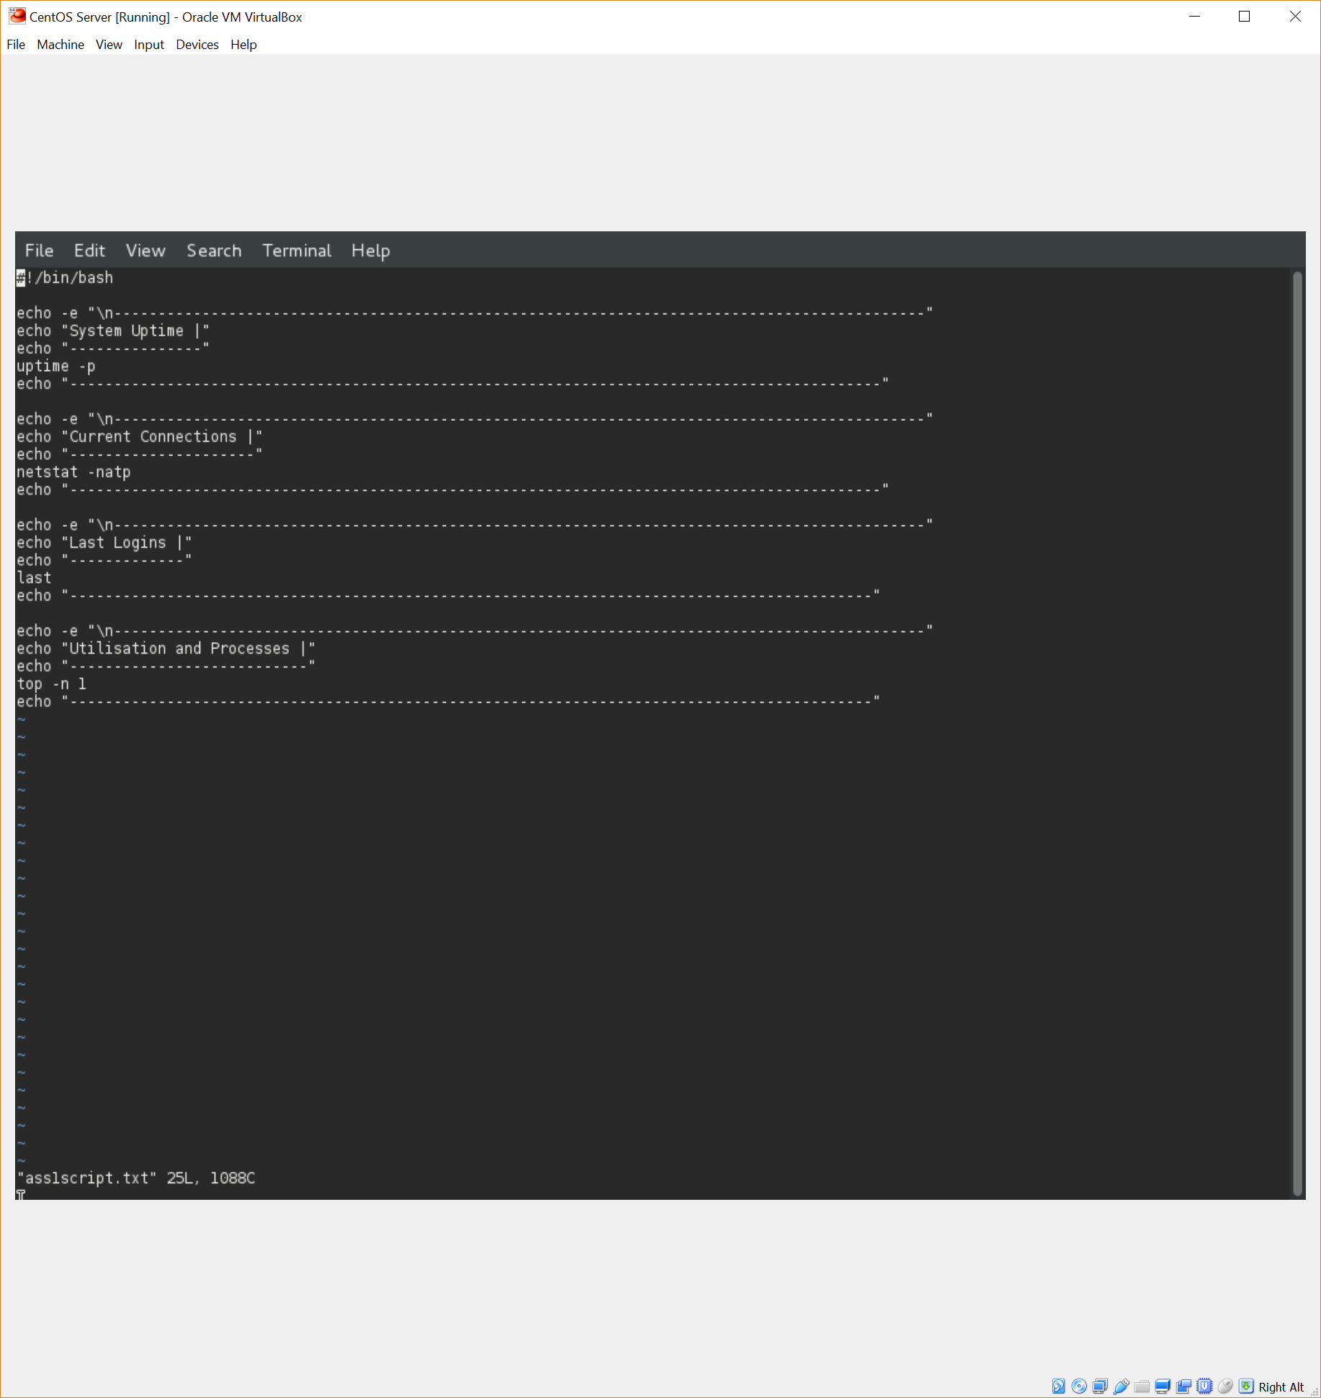

The second requirement of the script is to show the current connections. I didn’t feel that the specifics of this requirement were clear, so I assumed that active Internet connections is what was being requested. I was able to find a command which does exactly that - “netstat -natp” (Computer Hope, 2017). I inserted this into my script using the same visual formatting as the first command.

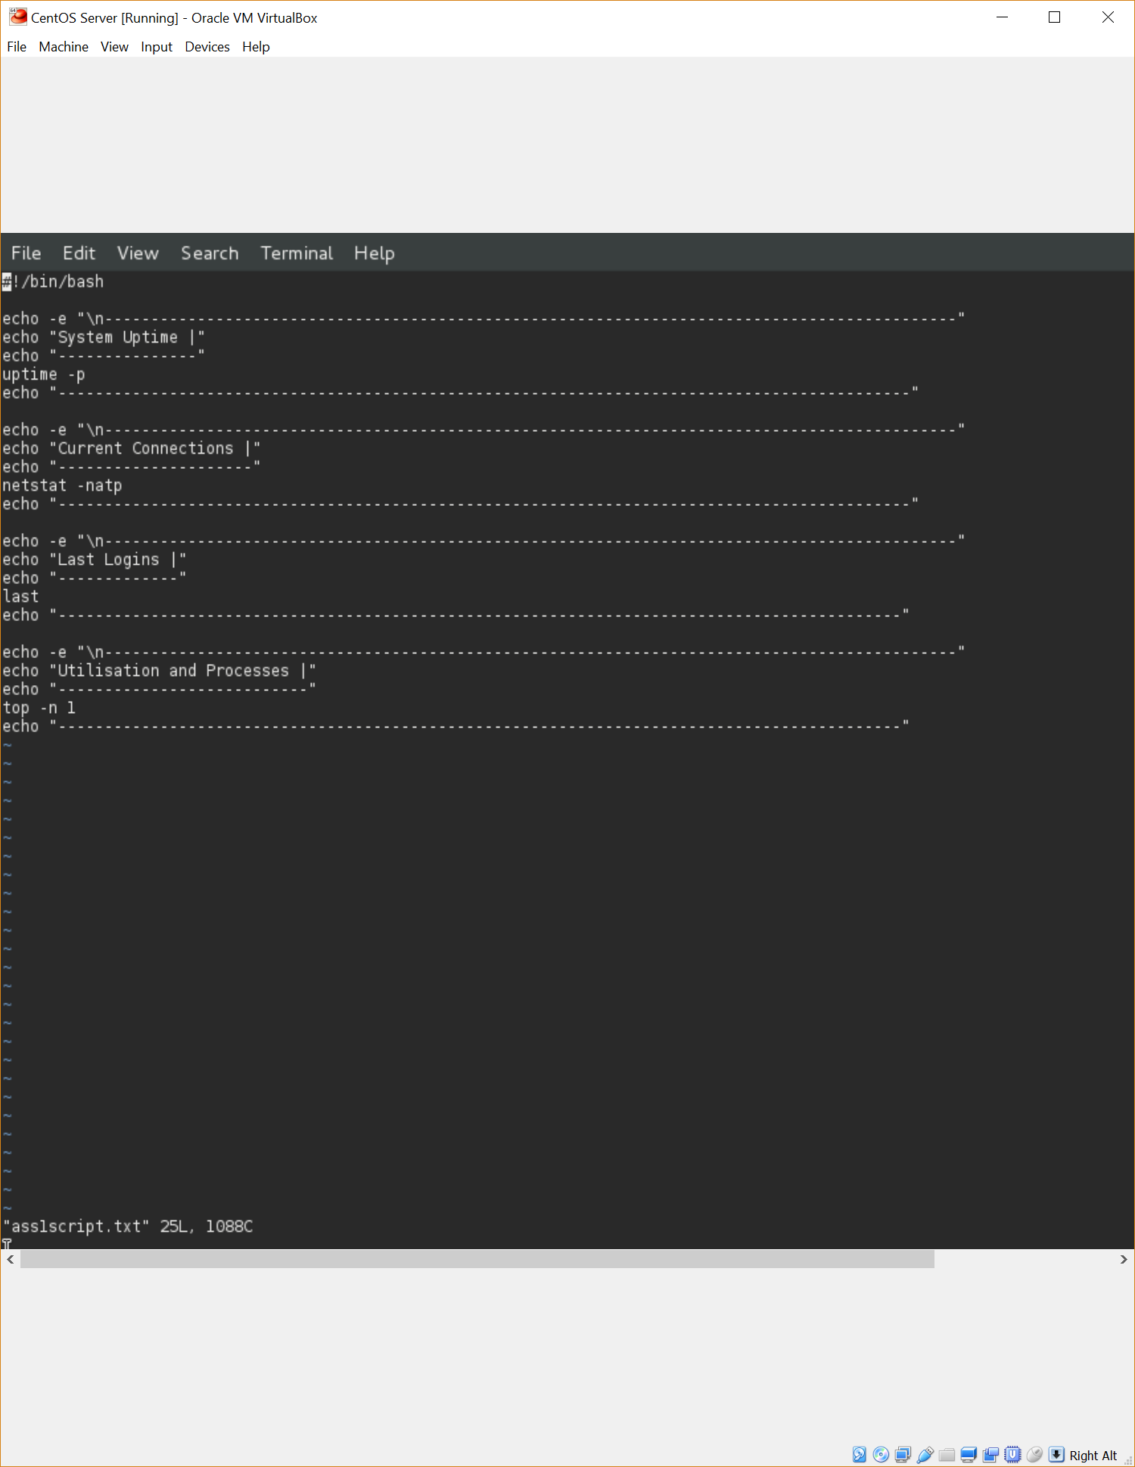

The third requirement of the script was to display the last logins of the system. This requirement was straightforward and very easy to find and implement (IT World, 2015, para. 3). Again, the same visual formatting was used as prior.



The fourth and final requirement was to display utilisation and processes with the highest CPU usage. This requirement was very easy to implement, as “top” displays both of these pieces of information (Tecmint, 2013, para. 12).



The next few screen captures show the output of the script.

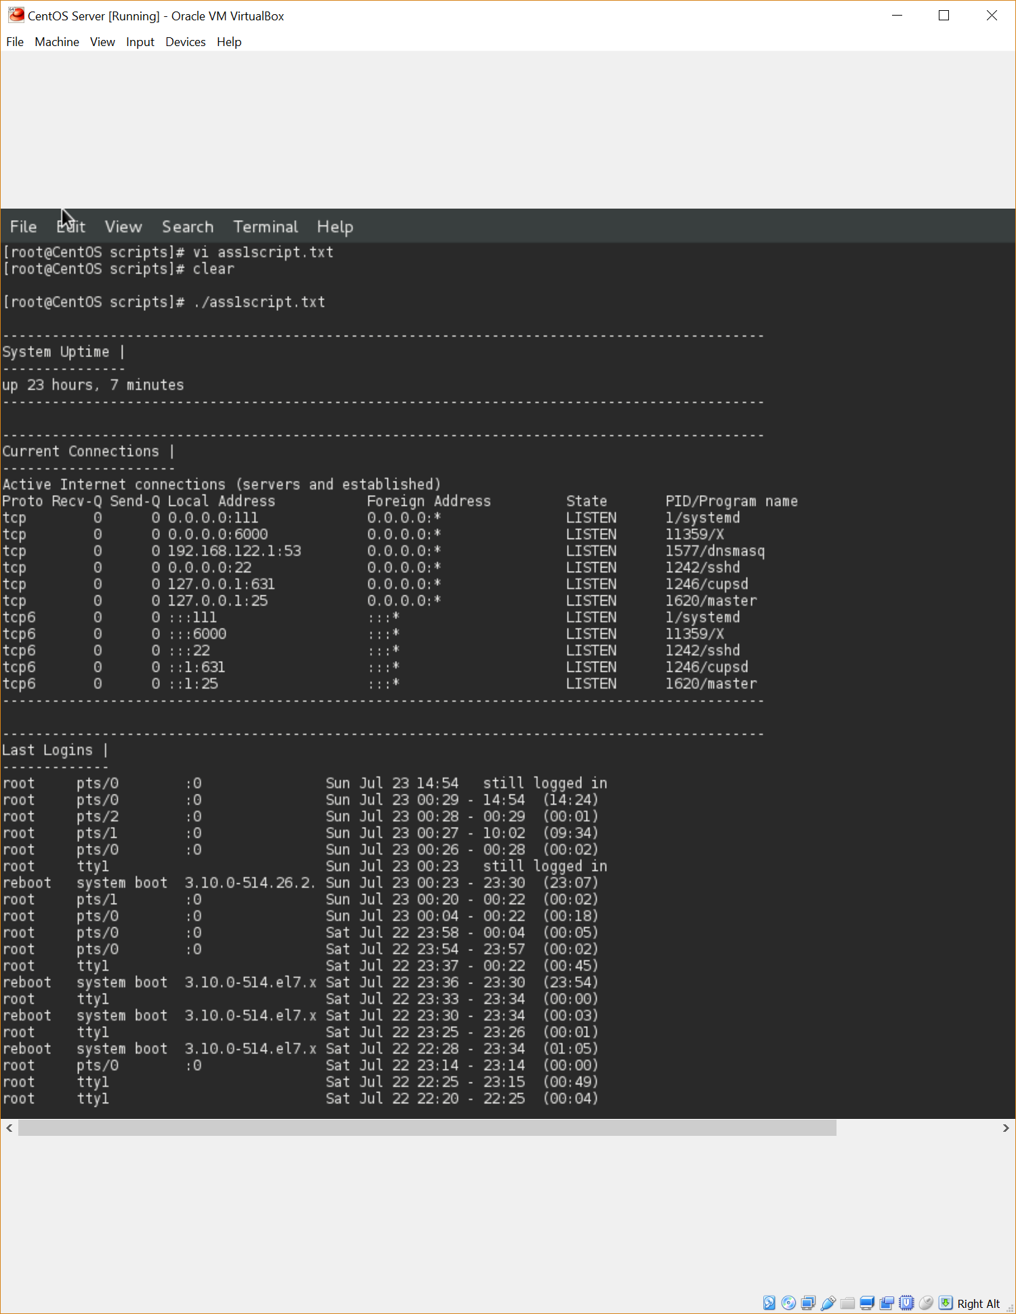

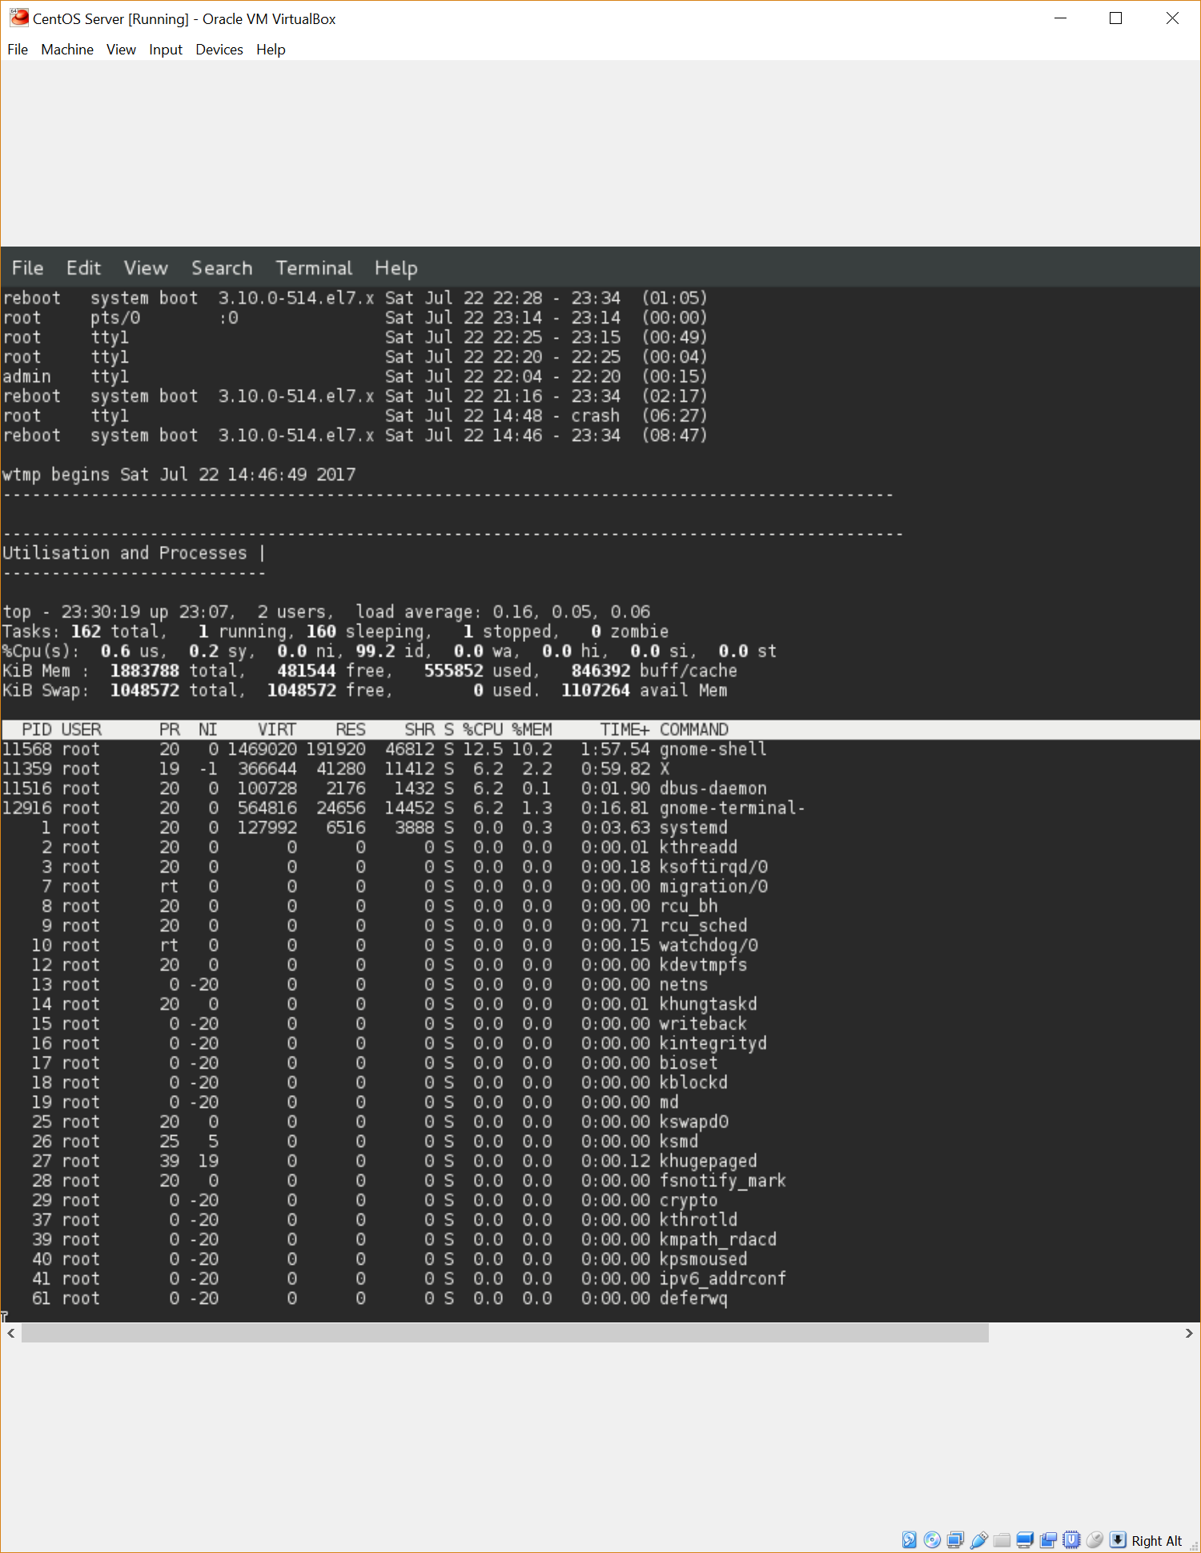

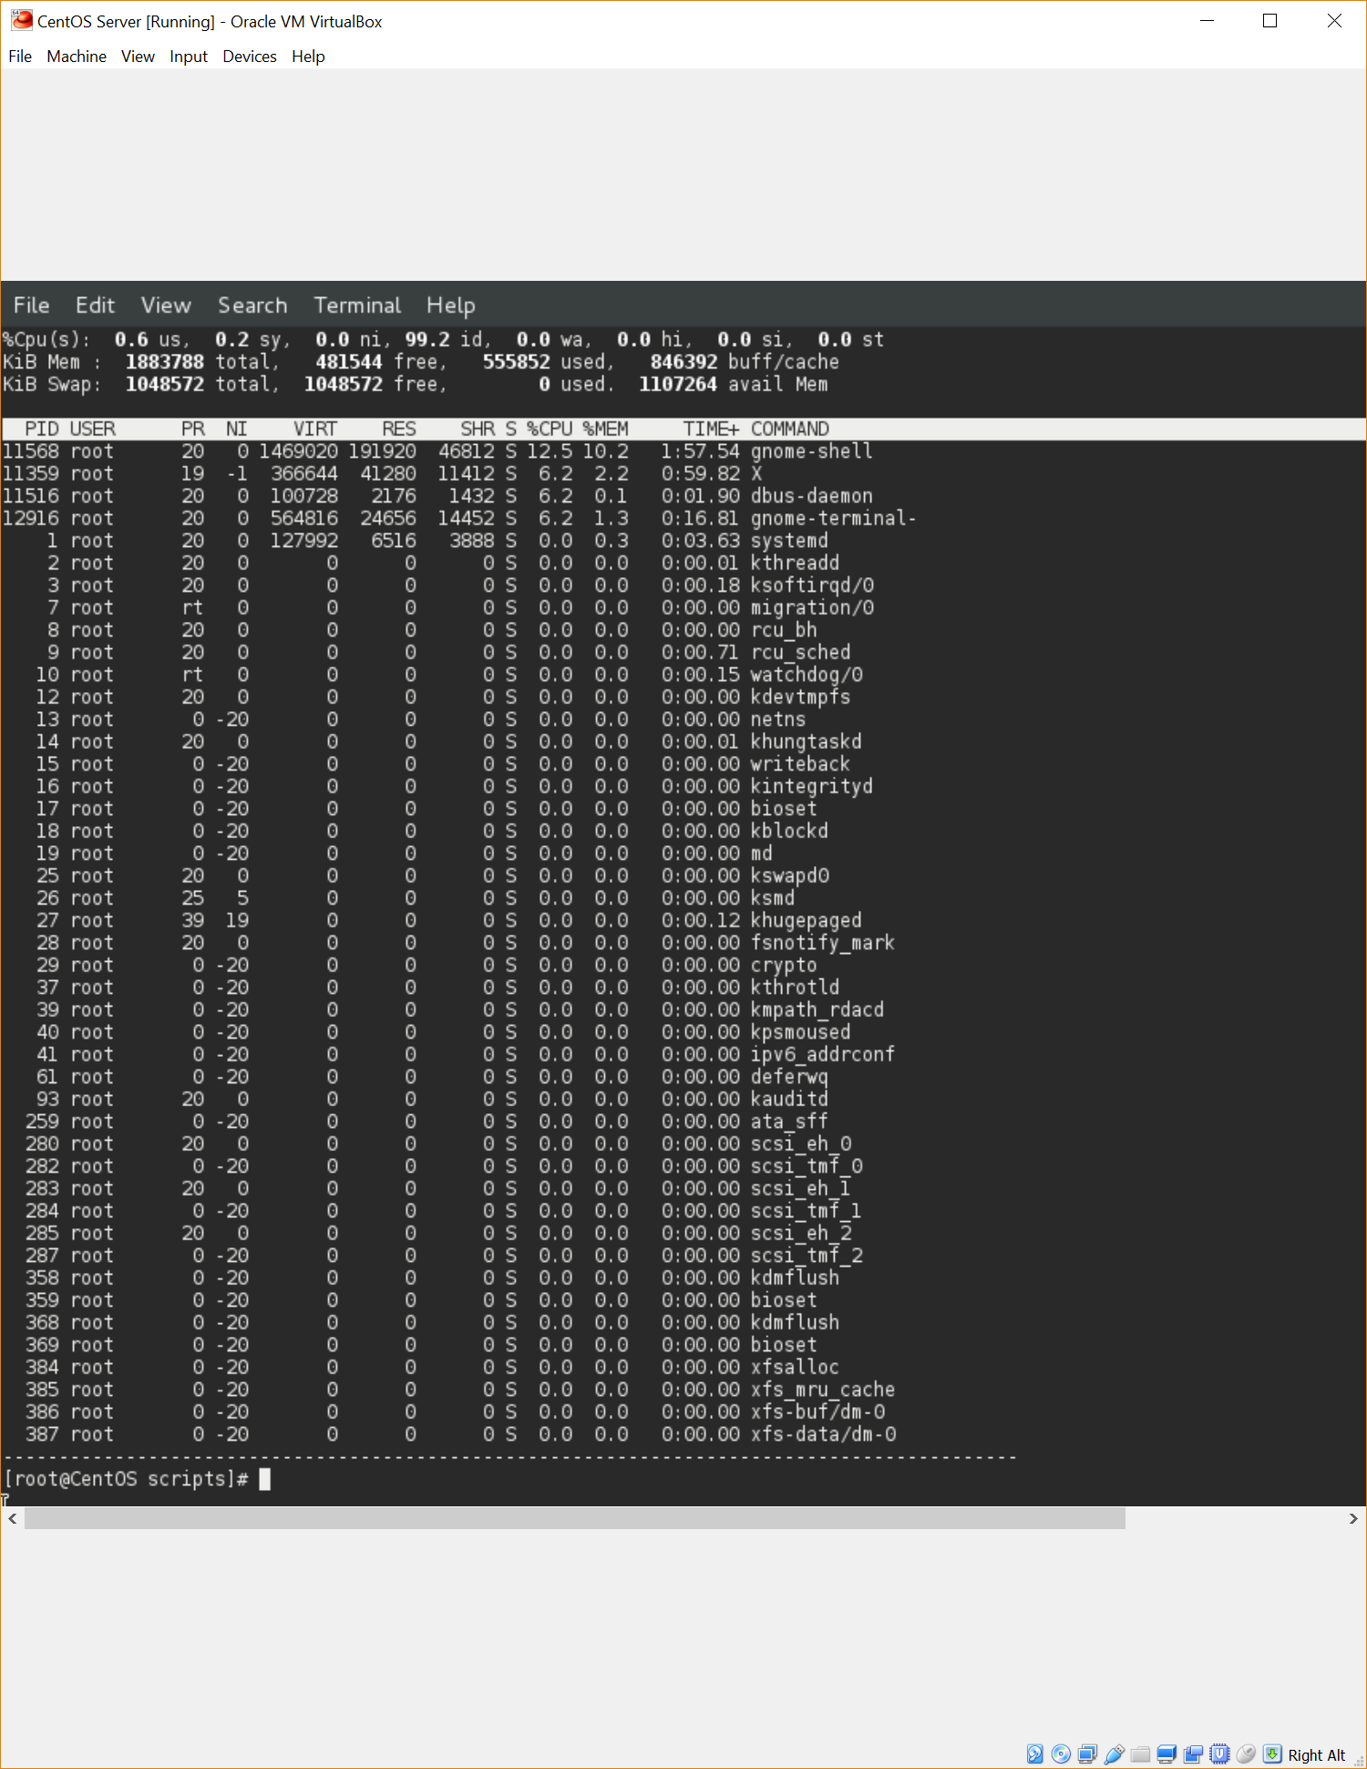

The research required along with the creation of this script took me 3 hours to complete.

## References

11.8. Uptime. (2017). Retrieved from <http://www.tldp.org/HOWTO/Bash-Prompt-HOWTO/x758.html>

CentOS-7 (1611) Release Notes. (2016, December 21). Retrieved from <https://wiki.centos.org/Manuals/ReleaseNotes/CentOS7#head-281c090cc4fbc6bb5c7d4cd82a266fce807eee7c>

Computer Hope. (2017). Displaying all active Internet connections in Linux. Retrieved from <https://www.computerhope.com/issues/ch001079.htm>

IT World. (2015). Checking last logins with lastlog*.* Retrieved from <http://www.itworld.com/article/2914650/linux/checking-last-logins-with-lastlog.html>

Nemeth, E., Snyder, G., Hein, T. R., & Whaley, B. (2011). Unix and Linux System Administration Handbook. Upper Saddle River, NJ: Pearson Education, Inc.

Oracle Corporation. (2017). *Oracle VM VirtualBox User Manual*. Retrieved from <http://www.virtualbox.org/manual/ch05.html#vdidetails>

systemd System and Service Manager. (2017, March 23). Retrieved from <https://www.freedesktop.org/wiki/Software/systemd/>

Tecmint. (2013). 12 TOP Command Examples in Linux. Retrieved from <https://www.tecmint.com/12-top-command-examples-in-linux/>

*watchdog(8) – Linux man page*. (2017)*.* Retrieved from <https://linux.die.net/man/8/watchdog>